Pre-IB Chemistry
Chemical Equilibrium — Revision Assignment
Name: ________________________________ | Date: __________________ | Total: _______ / 36
This assignment is designed to help you review the key concepts of chemical equilibrium. Work through each section carefully, using your notes and textbook as needed.
Section A: Dynamic equilibrium [8 marks]
Dynamic equilibrium
Key idea: At equilibrium, the forward and reverse reactions continue at equal rates. Macroscopic properties (colour, pressure, concentration) remain constant, but the system is not static.
1. Define the term dynamic equilibrium. [2]

2. The reaction below represents a reversible reaction at equilibrium. State TWO observable features of the system that would confirm it has reached equilibrium. [2]

A(g) + B(g) ⇌ C(g) + D(g) in a sealed container

Feature 1: ____________________________________________________________

Feature 2: ____________________________________________________________

3. Explain why equilibrium can only be established in a closed system. [2]

4. Complete the table by stating whether each property changes or stays constant at equilibrium. [2]
Property | Changes / Stays constant
Concentration of reactants
Rate of forward reaction
Rate of reverse reaction
Colour of the mixture
Section B: Le Châtelier’s principle [10 marks]
Le Châtelier’s principle
Key idea: When a stress (change in concentration, temperature, or pressure) is applied to a system at equilibrium, the system shifts to partially counteract that stress and establish a new equilibrium.
5. State Le Châtelier’s principle in your own words. [2]

6. Consider the following equilibrium: N₂(g) + 3 H₂(g) ⇌ 2 NH₃(g) ΔH = −92 kJ/mol

For each stress applied, state the direction of the equilibrium shift and give a reason. [6]
Stress applied | Direction of shift | Reason
Temperature is increased
More N₂ is added
Pressure is increased (volume decreased)
A catalyst is added
Some NH₃ is removed
Temperature is decreased

7. Explain why adding a catalyst does NOT change the position of equilibrium. [2]

Section C: Direction of equilibrium shift [10 marks]
Direction of shift
Key idea: Shifts are driven by changes in concentration, pressure (for gases), and temperature. Pressure changes affect equilibria only when there is a difference in the total moles of gas on each side.
8. For each reaction below, predict the direction of equilibrium shift when pressure is increased. Show your working by counting moles of gas. [4]
(a) 2 NO(g) + O₂(g) ⇌ 2 NO₂(g)
Moles of gas (left): ______ Moles of gas (right): ______ Direction of shift: ______________
(b) H₂(g) + I₂(g) ⇌ 2 HI(g)
Moles of gas (left): ______ Moles of gas (right): ______ Direction of shift: ______________

9. The equilibrium below involves the conversion of colorless NO₂ dimers to brown NO₂ gas:
N₂O₄(g) ⇌ 2 NO₂(g) ΔH = +57 kJ/mol (colorless ⇌ brown)
Predict and explain the colour change observed when: [4]
(a) The mixture is heated

(b) The pressure is increased

10. For the reaction: 2 SO₂(g) + O₂(g) ⇌ 2 SO₃(g) ΔH = −197 kJ/mol

State TWO changes that would increase the yield of SO₃, and for each explain the reasoning. [4]
Change 1:

Change 2:

Section D: Interpreting equilibrium graphs [8 marks]
Interpreting graphs
Key idea: On a concentration–time graph: flat lines indicate equilibrium; a sudden step change followed by a new flat region indicates a stress has been applied. The direction and magnitude of the change reveals what stress occurred.
11. The graph below (described in words) shows the concentration of reactant A and product B over time for the reaction A(g) ⇌ B(g).
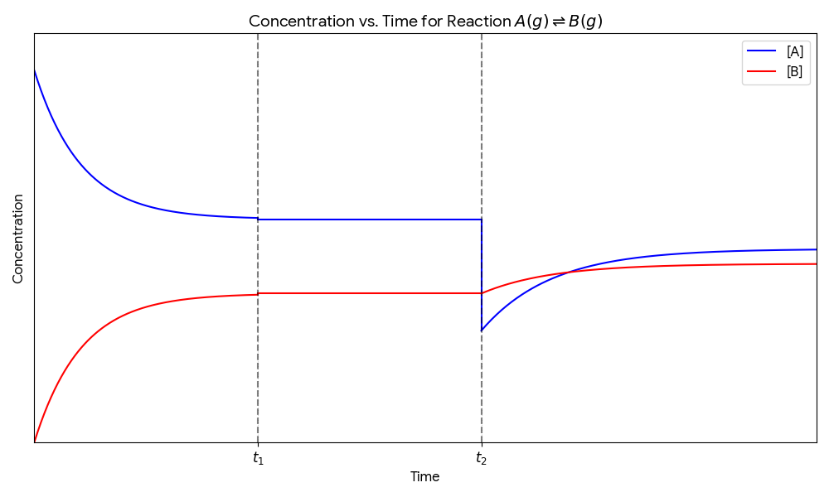
Answer the following questions about the graph: [4]
(a) What is happening between time 0 and t₁?

(b) What does the flat region after t₁ (before t₂) tell you about the system?

(c) What stress was most likely applied at t₂? Explain your reasoning.

12. Sketch the expected shape of a concentration–time graph for a system A ⇌ B starting with only A present, reaching equilibrium, then having more A added. Label the axes, equilibrium, and the point where A is added. [4]

Chemical Equilibrium — Revision Assignment Answer Key
Model answers and marking guidance are provided below. Accept any response that captures the essential scientific meaning. Mark allocations are shown in brackets.
Section A: Dynamic equilibrium
Q1 |  |  | Dynamic equilibrium
Answer: A state in which the forward and reverse reactions occur simultaneously at equal rates
Award 1 mark for “forward and reverse reactions occur at the same rate” and 1 mark for “macroscopic properties (concentration, colour, pressure) remain constant.” Students must convey that both reactions are still happening — the system is not static.

Q2 |  |  | Dynamic equilibrium
Answer: Any TWO of: constant colour; constant pressure; constant concentration of any species
Award 1 mark per valid observable feature (max 2). Acceptable answers include: the colour of the gas mixture does not change over time; the total pressure in the sealed container remains constant; the concentration of any reactant or product remains constant. Do not accept “the reaction has stopped.”

Q3 |  |  | Dynamic equilibrium
Answer: In an open system, products (or reactants) can escape, so concentrations keep changing and a stable equilibrium position is never established
Award 1 mark for identifying that substances can leave/enter in an open system, and 1 mark for explaining that this prevents a stable equilibrium from being established. The key idea is that equilibrium requires constant concentrations, which is only possible when matter cannot enter or leave.

Q4 |  |  | Dynamic equilibrium
Answer: Concentration of reactants: stays constant | Rate of forward reaction: stays constant | Rate of reverse reaction: stays constant | Colour of the mixture: stays constant
Award ½ mark per correct cell (total 2 marks). All four properties stay constant at equilibrium. A common misconception is that rates are zero — clarify that both rates are equal and non-zero, not that they have stopped.

Section B: Le Châtelier’s principle
Q5 |  |  | Le Chatelier’s principle
Answer: When a stress is applied to a system at equilibrium, the system will shift in the direction that partially opposes or reduces that stress
Award 1 mark for “stress is applied” and 1 mark for “system shifts to oppose/reduce the stress.” Accept equivalent wording. Students should not say the system “eliminates” the stress — it only partially counteracts it.

Q6 |  |  | Le Chatelier’s principle
Answer: See table below
Award 1 mark per row for a correct direction AND a correct reason (max 6 marks): • Temperature increased → Reverse (backward). Exothermic reaction — system absorbs heat by shifting in endothermic direction. • More N₂ added → Forward. Increased [N₂] — system consumes the added reactant. • Pressure increased → Forward. Left side has 4 mol gas; right has 2 mol — system shifts to reduce moles of gas. • Catalyst added → No shift. Catalyst speeds both forward and reverse equally; equilibrium position unchanged. • NH₃ removed → Forward. Decreased [NH₃] — system produces more product to restore equilibrium. • Temperature decreased → Forward. System releases heat by shifting in exothermic direction.

Q7 |  |  | Le Chatelier’s principle
Answer: A catalyst lowers the activation energy equally for both the forward and reverse reactions, so both rates increase by the same factor and the ratio of forward to reverse rate — and therefore the equilibrium position — does not change
Award 1 mark for “catalyst lowers activation energy for both forward and reverse reactions equally” and 1 mark for “therefore both rates increase by the same factor / equilibrium position unchanged.” Students must address both directions explicitly.

Section C: Direction of equilibrium shift
Q8 |  |  | Direction of shift
Answer: (a) Left: 3 mol gas, Right: 2 mol gas → Forward shift | (b) Left: 2 mol gas, Right: 2 mol gas → No shift
Award 1 mark per reaction for correct mole count AND correct direction (max 4 marks). For (a): 2 NO + O₂ = 3 mol left, 2 NO₂ = 2 mol right → increased pressure favours fewer moles → forward. For (b): 1 + 1 = 2 mol left, 2 HI = 2 mol right → equal moles on both sides → no shift in position (pressure change has no effect).

Q9 |  |  | Direction of shift
Answer: (a) Heating: mixture becomes darker/more brown. (b) Increased pressure: mixture becomes lighter/less brown.
Award 1 mark for direction and 1 mark for colour change per part (max 4 marks). (a) Heating adds energy; reaction is endothermic (ΔH = +57 kJ/mol) so equilibrium shifts forward, producing more NO₂ (brown) → mixture darkens. (b) Increasing pressure favours fewer moles of gas; left side has 1 mol, right has 2 mol, so equilibrium shifts backward, producing more N₂O₄ (colourless) → mixture becomes lighter/paler.

Q10 |  |  | Direction of shift
Answer: Any TWO of: (1) Decrease temperature — reaction is exothermic, lower T shifts equilibrium forward. (2) Increase pressure — left has 3 mol gas, right has 2, so higher pressure shifts forward. (3) Remove SO₃ — decreasing product concentration drives the reaction forward. (4) Add more SO₂ or O₂ — increasing reactant concentration shifts equilibrium forward.
Award 1 mark for each valid change and 1 mark for the correct, specific reasoning (max 4 marks, 2 changes × 2). Students must name the change AND explain the direction using Le Châtelier’s principle — a change alone is insufficient for full marks.

Section D: Interpreting equilibrium graphs
Q11 |  |  | Interpreting graphs
Answer: (a) The reaction is proceeding: A is being converted to B; concentrations are still changing. (b) The system has reached equilibrium — concentrations of A and B are constant. (c) Some A was removed — the sudden drop in [A] followed by a gradual return to a new lower equilibrium level is consistent with removal of reactant.
Award 1 mark per part (max 4 marks). (a) Accept: “reactants converting to products” or “system moving toward equilibrium.” (b) Must include: forward and reverse rates are equal; concentrations are no longer changing. (c) Full marks require both identification of the stress (removal of A) AND a reason linked to graph shape (sudden drop then partial recovery). If student says “some A was consumed” that alone does not explain the sudden step — push for the link to removal vs. consumption.

Q12 |  |  | Interpreting graphs
Answer: Graph should show: [A] decreasing curve, [B] increasing curve, both levelling off (equilibrium). Then at the labelled point, [A] spikes up suddenly, [B] dips slightly, then both reach new flat equilibrium levels ([A] higher than original, [B] lower than original equilibrium).
Award 1 mark per correct feature (max 4 marks): (1) Correct shape of initial approach to equilibrium for both A and B. (2) Axes labelled (Concentration on y-axis, Time on x-axis). (3) Equilibrium region correctly identified (flat lines). (4) Point of A addition marked, with [A] showing a step increase and then partial decrease to new equilibrium, and [B] showing slight dip then rise to new slightly lower equilibrium.

Pre-IB Chemistry

