Titration Practical Name __________________________

Titration is a common laboratory technique used to determine the concentration of a substance in a solution. In this case, we will be performing a titration with sodium hydroxide (NaOH) and hydrochloric acid (HCl) to determine the concentration of HCl solution. Here is a detailed method for performing the titration, along with safety and environmental concerns:
Materials Required:
- Sodium hydroxide (NaOH) 0.1 M
- Hydrochloric acid (HCl) 0.1 M
- Distilled water
- Phenolphthalein indicator
- Burette
- Conical flask
- Pipette
- Beaker
- Safety goggles
- Lab coat
- Gloves
Safety Precautions:
- Wear safety goggles, lab coat, and gloves to protect your eyes, skin, and clothing from chemical spills or splashes.
- Handle NaOH and HCl with extreme caution as they are corrosive and can cause severe burns.
- Avoid inhaling the vapors produced during the titration, as they can irritate your respiratory system.
- Always use distilled water for diluting the solutions to avoid any impurities in the water.
- Keep a neutralizing solution of 1% sodium bicarbonate on hand in case of accidental spills or splashes.
Environmental Concerns:
- Dispose of all chemical wastes according to local regulations and guidelines.

- Rinse all glassware thoroughly with water before disposal.
- Never pour any chemicals down the drain or in the trash.
Procedure:
- Using a pipette, measure out 25.0 cm³ of the HCl solution using a volumetric pipette and transfer it to a clean conical flask.
- Add 3 drops of phenolphthalein indicator to the HCl solution in the flask.
- Place the conical flask on a stir plate, adding a stir bar to the HCl. Set the stir setting to 3-4.
- Set up the burette using a ring stand and a burette clamp so the burette is positioned above the conical flask.
- Wash and fill the burette with the NaOH solution using a funnel and note the initial burette reading.
- Slowly add the NaOH solution from the burette into the HCl solution in the conical flask until a faint pink color appears, but disappears immediately.
- Continue adding NaOH solution dropwise until the pink colour of the indicator just disappears. This is known as the endpoint of the titration.
- Record the final burette reading.
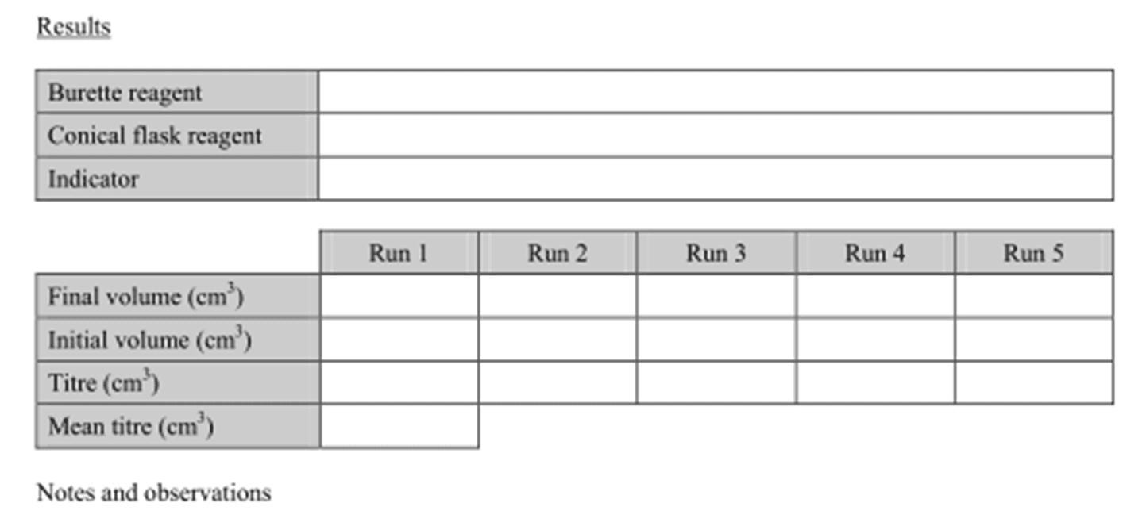
- Repeat the titration two more times to obtain an average volume of NaOH required to neutralize the HCl.

- Write the balanced chemical equation of the reaction.
- Calculate the amount of moles of NaOH required to neutralize the HCl.
- Calculate the number of moles of HCl that were in the conical flask.
- Calculate the concentration of HCl in the conical flask.
- Propagate the uncertainty of the concentration of HCl.

