Gas Laws Practice Problems: Independent Work Name ________________________
- Which change in conditions would increase the volume of a fixed mass of gas?
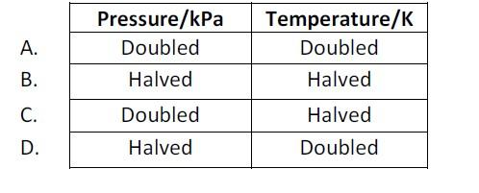
- All of the following are characteristic properties of gases EXCEPT
A. They can expand without limit.
  - They diffuse readily.
  - They are easily compressed.
  - They have high densities.

3. Which pressure expression represents the density of a gas sample of relative molar mass, Mr, at temperature, T, and pressure, P?
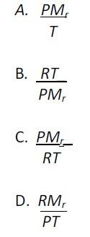
- Which of the following best accounts for the observation that gases are easily compressed?
A. Gas molecules have negligible attractive forces for one another.
  - The volume occupied by the gas is much greater than that occupied by the molecules.
  - The average energy of the molecules in a gas is proportional to the absolute temperature of the gas.
  - The collisions between gas molecules are elastic.
- In which gas sample do the molecules have the greatest average kinetic energy?
  - H₂ at 100 K
  - CH₄ at 273 K
  - H₂O at 373 K
  - CH₃OH at 353 K

- The temperature in Kelvin of 2.0 dm³ of an ideal gas is doubled and its pressure is increased by a factor of four. What is the final volume of the gas?
  - 1.0 dm³
  - 2.0 dm³
  - 3.0 dm³
  - 4.0 dm³
- When the pressure is increased at constant temperature, the particles in a gas will:
  - become smaller
  - become larger
  - move faster
  - be closer together

- Which quantity will not change for a sample of gas in a sealed rigid container when it is cooled from 100°C to 75°C at a constant volume?
  - The average kinetic energy of the molecules
  - The pressure of the gas
  - The density of the gas

- When a bicycle tire is pumped up with air at constant temperature, assuming any change in its volume can be neglected, the pressure increase comes from the fact that:
  - The gas particles are moving faster.
  - The collisions with the wall occur at a greater frequency.
  - Each collision transfers more momentum to the wall than before.
  - Two or three of the changes mentioned in A, B, and C occur simultaneously.

- 1 dm³ of gas in a container at -73⁰C is allowed to expand to 1.5 dm³, what must the temperature be increased to so that the pressure remains constant?
- A 2.00 dm³ of a gas at a pressure of 1000. kPa is allowed to expand at constant temperature until the pressure decreases to 300 kPa. What will the new volume of the gas be?
- In a particular experiment, aluminum was reacted with dilute hydrochloric acid according to the equation:
2 Al Is) + 6 HCl(aq) 🡪 2 AlCl3(aq) + 3 H2 (g)
355 cm³ of hydrogen was collected at 25.0 ⁰C and 100.0 kPa.
- Calculate how many moles of hydrogen were collected.
- If 0.300 g of aluminum was used with excess acid, determine the percentage yield of hydrogen.
- The following readings were taken during the determination of the molar mass of a gas by direct weighing. If the experiment was carried out at 23⁰C and 97.7 kPa, calculate the molar mass of the gas.
Mass of evacuated flask 183.257 g
Mass of flask and gas 187.942 g
Mass of flask filled with water 987.560 g
- A toxic gas, A, consists of 53.8 % nitrogen and 46.2 % carbon by mass. At 273 K and
1.01×10⁵ Pa, 1.048 g of A occupies 462 cm³. Determine the empirical formula of A. Calculate the molar mass of the compound and determine its molecular structure.

