Lab: Determining the Gibbs Free Energy Change of a NiMH Battery During Discharge vs. Recharge

Research Question:
How does the Gibbs free energy change (ΔG) differ during the discharge and recharge of a nickel-metal hydride (NiMH) battery?

Background Theory:
Nickel-metal hydride (NiMH) batteries are a type of rechargeable electrochemical cell widely used in portable electronics, cordless tools, and hybrid vehicles. They are valued for their high energy density, environmental safety, and reusability compared to older technologies like nickel-cadmium (NiCd) batteries.

Chemical Reactions:
A typical NiMH battery consists of:
- Positive electrode (cathode): nickel oxyhydroxide
NiO(OH) + H₂O + e−→ Ni(OH)₂ + OH⁻
- Negative electrode (anode): metal hydride (commonly a lanthanide-based alloy)
MH + OH⁻→ M + H₂O + e⁻
- The overall redox reaction during discharge is:
MH + NiO(OH) → M + Ni(OH)₂

This reaction is reversible, allowing the battery to be recharged by applying an external voltage. During charging, the reverse redox reactions occur, restoring the original chemical species.

Rechargeability and Efficiency
NiMH batteries are secondary cells, meaning they can undergo multiple charge-discharge cycles. However, they are not perfectly reversible:
- Overpotentials and internal resistance lead to energy losses.
- The recharge reaction requires more energy than is released during discharge.
- This energy inefficiency manifests as a smaller absolute Gibbs free energy (ΔG) during recharging compared to discharging.
- Discharge (galvanic): spontaneous, ΔG<0
- Recharge (electrolytic): non-spontaneous, ΔG>0
These differences can be quantified experimentally using the relationship:
ΔG=−nFE
Where:
- ΔG is the Gibbs free energy change (J/mol),
- n is the number of moles of electrons transferred (usually 1 for NiMH cells),
- F is the Faraday constant (96,500 C/mol e−
- E is the cell potential (V).
By measuring E_{cell} during both discharge and recharge phases, the energy comparison between the processes can be determined.
During Discharge:
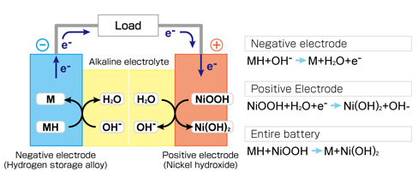

During Recharge:
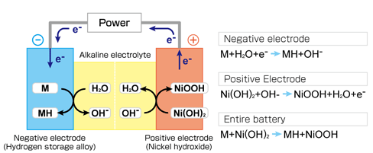

Hypothesis:
The magnitude of the Gibbs free energy change is greater during recharging than during discharge, due to internal losses and the non-spontaneous nature of the charging process.

Variables:
Type | Variable
Independent | Battery process (discharge vs. recharge)
Dependent | Measured cell potential (EMF), and calculated ΔG
Controlled | Battery type, ambient temperature, lightbulb resistance, circuit setup, time intervals

Materials:
- 1.5 V AA NiMH rechargeable battery (fully charged)
- 5/20 Ω resistors
- Alligator clip wires
- Digital multimeter or voltage probe
- Stopwatch
- Power supply or battery charger compatible with NiMH
- Thermometer (optional for monitoring ambient temperature)

Method:

Part A: Discharge of the NiMH Battery
- Ensure the battery is fully charged.
- Connect the battery to a closed circuit using a resistor.
- Begin timing and record the voltage across the battery terminals every 30 seconds for 10–15 minutes or until the voltage drops significantly (e.g., below 1.0 V).
- Calculate the average EMF per minute during discharge.
- Use the formula ΔG=−nFE_{avg} to calculate ΔG for the discharge.

Part B: Recharge of the NiMH Battery
- Immediately connect the discharged battery to a charger or power supply set to the appropriate voltage and current for NiMH cells (e.g., ~1.4 V, 200–300 mA).
- Record the voltage across the battery terminals every 30 seconds during the recharging process.
- Stop recording once the battery reaches full charge (~1.4-1.5 V).
Calculate the average EMF during charging.
- Use the same equation to calculate ΔG during recharge.

Data Collection Table (Sample):
Time (s) | Voltage during Discharge (V) | Voltage during Recharge (V)
0
30
60
90

Data Analysis:
- Plot voltage vs. time for both discharge and recharge.

____________________________________________________________________________


____________________________________________________________________________
- Determine the average voltage and average EMF per minute for each process.

- Compare the magnitude and sign of ΔG for both processes.

Conclusion Questions:
- Was the Gibbs free energy more positive or more negative during charging vs. discharging?

- How do the experimental results support your understanding of spontaneous vs. non-spontaneous processes?

- What factors might explain differences in the magnitudes of ΔG?

Evaluation:
Discuss how the possible sources of error contributed to the reliability and conclusion drawn from the data:
- Voltage drops due to internal resistance.
- Incomplete charge/discharge cycles.
- Heat generation affecting measurements.
- Inaccuracy in voltage readings.

