Name:____________________________________

Simulation Activity: Metals in Aqueous Solutions

Background
Some elements are more reactive than others, meaning that they are more likely to form compounds than to be found in their pure elemental or “free” form. Other elements are less reactive and more likely to be found as pure elements, not in a compound. This simulation will allow you to test various combinations of elements and compounds to put a selection of elements in order from most reactive to least reactive – a list called an activity series. More reactive elements will replace less reactive elements in a compound given the opportunity to react. Less reactive elements will remain as pure elements and will not react with compounds containing more reactive elements.

Objective
Use the results of the simulated experiments to determine the activity series for the elements used in this simulation.

Instructions
Access the simulation at https://teachchemistry.org/classroom-resources/metals-in-aqueous-solutions-simulation and complete each activity, recording the appropriate information and answering the questions below.

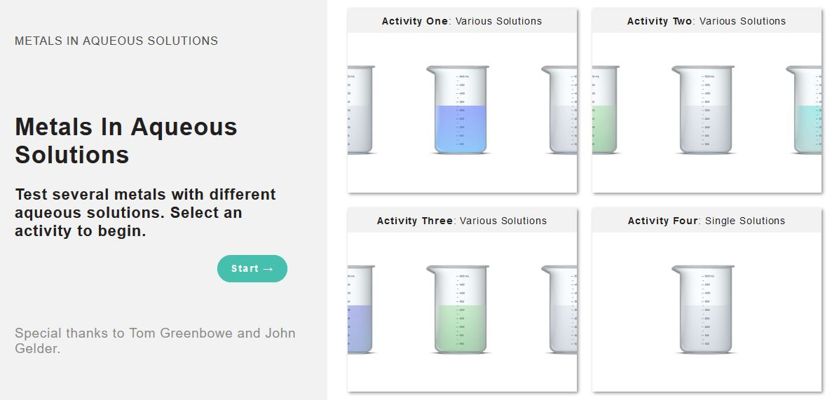
Activity 1
- Select one of the metals and follow the instructions on the simulation to test its interaction with each of the solutions.
- Determine which combinations of elements and solutions react and which do not. Record your observations of any changes you see in the metals or the solutions in Table 1 below. If you do not see any changes, write “No reaction.”
  - Click on “See Molecular Scale” to see how particles are interacting.
- Repeat steps A and B for the three remaining metals.

 | Mg(NO₃)₂ (aq)  Mg⁺² | Zn(NO₃)₂ (aq)  Zn²⁺ | Cu(NO₃)₂ (aq)  Cu²⁺ | AgNO₃ (aq)  Ag⁺
Mg
Zn
Cu
Ag
Table 1
Analysis
- Write and balance a complete chemical equation for each reaction you observed.

- Based on the observations you recorded in Table 1 and the reactions you wrote in the previous question, what criteria can you use to determine which metal is the most reactive and which one is the least reactive?

- Using the criteria you noted in question 1b., put the elements from Activity 1 in order from most reactive (at the top) to least reactive (at the bottom) in the list below.
Most reactive
Least reactive

- Look at the element on the top of your list.
  - Which elements from the list did it replace in a compound? In other words, what metal ions in the solutions did it react with?

  - Explain how you can use an element’s location on this list to determine whether or not it will react with a solution containing a cation of another element on the list.

  - Does this pattern hold true for the other elements on the list? Explain using another element from the list as an example.

- Pick a combination of metal and solution that did have a reaction and describe what happens in the molecular view. Compare and contrast this to the molecular view of one of the non-reacting combinations of metal and solution.

- What particles are shown in the molecular view? What particles would be present in real life but are not shown in the molecular view? Why do you think those particles were excluded?

