Redox Titrations Worksheet Name ________________________

1) Which of the following could be titrated using acidified MnO₄⁻ ions? Circle the correct answer. (1 mark)
Na⁺ IO3⁻ SO4²⁻ H₂O₂
2) Which of the following acidified solutions could be used to determine the [Sn²⁺] by redox titration? Circle the correct answer (1 mark)
I⁻ Co²⁺ Cr³⁺ Cr₂O₇²⁻
3) Consider the following redox reaction in acidic solution:
MnO₄⁻ + H₂O₂ → Mn²⁺ + O₂

a) Write a balanced equation for the above reaction. (4 marks)

-
b) The above reaction was used for a redox titration. At the equivalence point 6.725 x 10⁻⁴ mol KMnO₄ was required to titrate 7.50 mL of H₂O₂ solution. Calculate the [H₂O₂]. (2 marks)

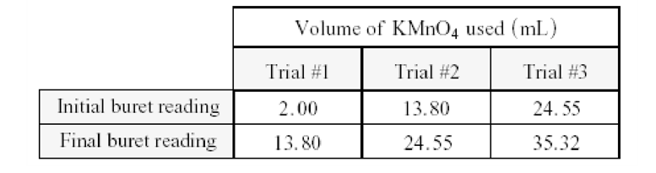
4) The data below were obtained in a redox titration of a 30.00 cm³ sample containing Sn²⁺ ions using 0.150 mol dm⁻³ KMnO₄.

Calculate the [Sn²⁺] in the original sample. (4 marks)

5) An impure sample of CaC₂O₄ weighing 0.793 g is titrated with 17.30 cm³ of 0.125 mol dm⁻³ KMnO₄. What is the percent by mass of the CaC₂O₄ in the original sample? (4 marks) Hint: carbon dioxide and water are produced in the reaction.

