Practice Problems: Electrolytic Cells Name ________________________
Write answers on a separate sheet of paper.
1 . Consider the following unbalanced redox reactions:
- I₂(s) + Cl⁻ (aq) 🡪 I⁻ (aq) + Cl₂(g)
- MnO₄⁻(aq) + Br⁻(aq) 🡪 Br₂(l) + Mn ²⁺ (aq) (acidic conditions)
For each un-balanced redox reaction above:
i. indicate if the reaction is spontaneous or not
ii. write out the half-reaction at the anode
iii. write out the half-reaction at the cathode
iv. write out the balanced redox reaction
v. calculate the cell potential
vi. indicate if it is a redox reaction that can take place in a voltaic cell or electrolytic cell

- Oxidation takes place at what electrode in a voltaic cell?
- Oxidation takes place at what electrode in an electrolytic cell?
- An electrolytic cell and a voltaic cell can look very similar except for the presence or absence of what?
- In a voltaic cell, electrons flow out of which electrode?
- In an electrolytic cell, electrons flow out of which electrode?
- Consider an electrolytic nickel-cadmium cell.
  - Identify the anode and cathode.
  - Write out the oxidation half-reaction, the reduction half-reaction, and the net redox reaction.
  - Calculate the cell potential.
- Consider the electrolysis of Kl(aq).
  - Identify and write out the half-reactions that occur at the anode and cathode.
  - Write out the redox reaction that occurs in the electrolysis process.
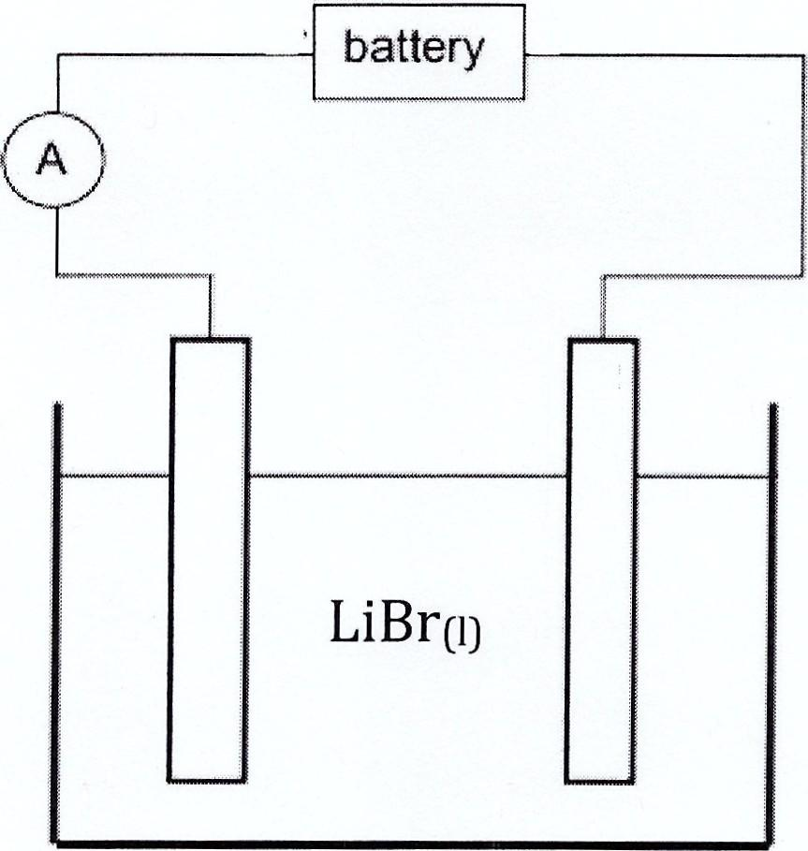
  - Label the electrolytic cell:
*Direction of electron flow
*Label the anode and cathode
*Charge of anode and cathode
*Draw ions and products at each electrode

- Consider the electrolysis of NaCl(aq).
- Identify and write out the half-reactions that occur at the anode and cathode.
- Write the redox reaction that occurs in the electrolytic cell.
- Label the electrolytic cell:
*Direction of electron flow
*Label the anode and cathode
*Charge of anode and cathode
*Draw ions and products at each electrode

10. Predict whether the following reaction would take place in a voltaic cell or an electrolytic cell.
- 2 Ag⁺(aq) + H₂SO₃(aq) + H₂O(l) 🡪 2 Ag(s) + S0₄²⁻(aq) + 4H⁺(aq)
- FeI₂(aq) 🡪 Fe(s) + I₂(s)

11. In the electrolysis of water, identify the gas produced at the anode and identify the gas
produced at the cathode.

12. Consider the electrolysis of molten lithium bromide, LiBr(l).
  - Write the half-reactions that take place at the anode and the cathode.
  - What voltage is required for this electrolysis purpose?
  - Will the mass of the cathode increase or decrease?
  - Correctly label the diagram below with the direction of electron flow and the location Br₂(l) forms.

13. Consider the picture of the following electrochemical cell.

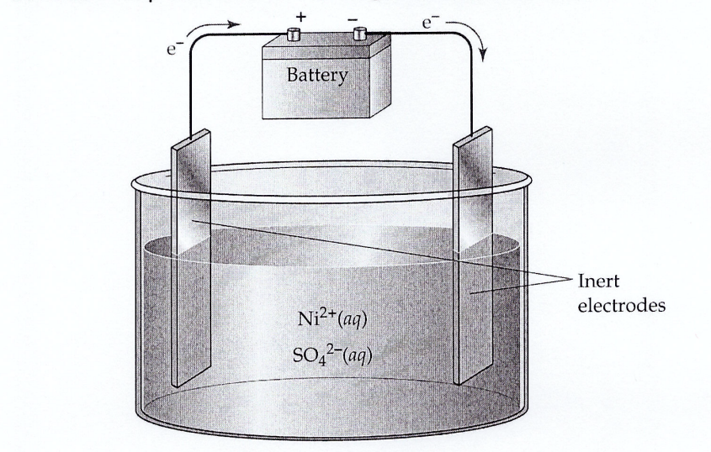

  - Is the cell electrolytic or voltaic?
  - What side is the anode located (left or right)?
  - Write the half-reaction that takes place at the anode and cathode.
d. Calculate the cell potential.

