Reactivity of Metals Lab
Purpose: To measure how the atomic radius of various metals affects their reactivity with HCl using the volume of H₂ gas produced.
- Measure 50 cm³ of 1 mol dm⁻³ hydrochloric acid using a graduated cylinder and pour into a 100 cm³ Erlenmeyer flask.
- Set up the apparatus as shown in the diagram. Half-fill the trough with water.
- Fill a 100 cm³ graduated cylinder with water, and make sure that it stays filled with water when you turn it upside down.
- Cut an approximate 3 cm strip of magnesium and measure the mass on an electronic balance. It should be approximately 0.05 g.
- Quickly add the magnesium ribbon to the Erlenmeyer flask with the HCl and place the rubber stopper (bung) back into the flask, and start the stopwatch.
- Continue timing until no more gas appears to be given off. Record the volume of hydrogen gas produced by measuring the change in volume in the graduated cylinder.
- Neutralize the excess acid using baking soda and check the pH using a pH strip. Once the pH is 7, the solution can be poured down the drain (make sure the reacted metal is thrown in the trash can).
- Repeat steps 1-7 using granular Zn, Sn, Ca, Al, Si, and Ni metals. Make sure to record the mass of each metal accurately (about 0.05 g of each metal should be used).
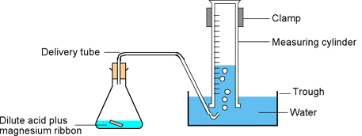
Example equation: Mg(s) + 2HCl(aq) → MgCl₂(aq) + H₂(g)
In this reaction, the acid is in excess, so it is the surface area of metal exposed to the acid that is the limiting reagent. In your writeup, make sure to include the equations of each reaction that occurs. Also include a graph of independent vs. dependent variables, including a best fit line of the data. The rate of each reaction can be found by calculating the moles of hydrogen gas produced and dividing it by the time it took for the reaction to reach completion.

