Isotopes and Mass Spectrometry Name _______________________________

Why? In this activity we will address the questions:

- Are all atoms of an element identical and how do we know?
- How can data from mass spectrometry be used to identify the elements and the masses of individual atoms of a specific element.
- How can Data from mass spectrometry also demonstrate direct evidence of different isotopes from the same element?
- How can the average atomic mass be estimated from mass spectra.
- Explain how data from mass spectrometry supports or rejects early models of the atom.

Part 1: Mass spectrometry
Information:
Mass Spectrometry is a powerful analytical tool used to determine the following information.
- The elemental composition of a sample
- The masses of particles and of molecules
- Potential chemical structures of molecules by analyzing the fragments
- The identity of unknown compounds by determining mass and matching to known spectra
- The isotopic composition of elements in a sample

A mass spectrometer is a device for separating atoms and molecules according to their mass. In a mass spectrometer, a substance is first heated in a vacuum and then ionized. The ions produced are accelerated through a magnetic field that separates ions of different masses. The height of each peak is proportional to the amount of each isotope present (i.e. it’s relative abundance). The m/z ratio for each peak is found from the accelerating voltage for each peak. Many ions have a +1 charge so that the m/z ratio is numerically equal to mass m of the ion.

The graph below was produced when an element, potassium, was analyzed in a mass spectrometer. Use the graph to answer the questions below.
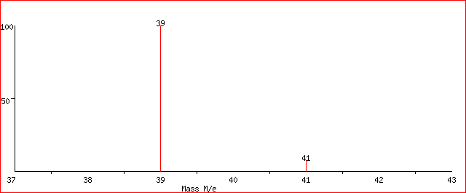

Isotope mass Rel. Intensity
- amu 100
- amu 7.2

Mass spectrum of Lithium

- How many isotopes of potassium exist?

- What masses are present on the graph for the following

  - The mass of the most abundant isotope

  - The mass of the least abundant isotope.

- Label the each peak with the nuclide symbol for each isotope

- Without performing any calculations, predict the approximate atomic mass for potassium. Explain the basis for your prediction.

- Now calculate the average atomic mass of the element from the mass spectrum data. The height of each peak is the relative intensity, not the % abundance. You will first need to calculate the % abundance and then the average atomic mass.

  - What is the relative intensity of each peak?

Peak 1 = ____________

Peak 2 = ____________

  - What is the total relative intensity of the peaks?

Total = __________

  - What is the % of the intensity of each peak? (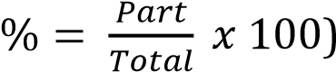

Peak 1% = __________

Peak 2% = __________

  - You’ve just determined the % abundance for each isotope of the element. Complete the table and calculate the average atomic mass of the element.

Isotope | Mass | % Abundance

Average atomic mass = __________amu

- The modern use of mass spectrometry provides another example of how experimental data can be used to test or reject a scientific model.

  - Does data from mass spectrometry demonstrate evidence which supports or contradicts Dalton’s early model of the atom? Explain.

  - How does data from mass spectrometry demonstrate direct evidence of different isotopes of the same element?

- What element’s mass spectrum is represented below? Explain your answer.
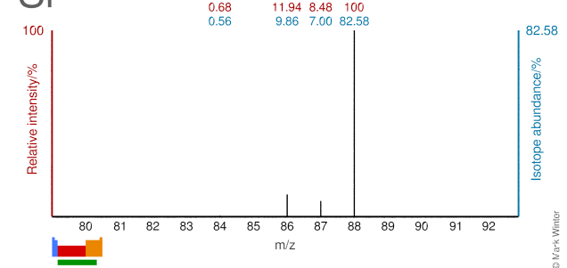

Model 3: Predicting Isotopic Abundances and Mass Spectrum

Based on what you’ve learned, answer the following questions and check your answers using one of the following websites

- http://www.webelements.com Select the element of interest. Scroll to the bottom right of the page and click on “Isotopes” under the “Nuclear Properties” section.

- http://www.sisweb.com/mstools/isotope.htm Enter in the formula of the element to generate its mass spectrum. (Note: formula entry is case sensitive; the first letter of the element must be capitalized and all others lower case.

  - a) What is the average atomic mass of Magnesium?

    - If there are three predominant isotopes of magnesium on earth, ²⁴Mg, ²⁵Mg, and , ²⁶Mg, which do you think is most abundant? Why?

    - Make an estimate of the percentage of each isotope of magnesium.

    - Draw a rough sketch for the mass spectrum of magnesium. Label each axis and label each peak with the appropriate nuclide symbol

  - There are two naturally occurring isotopes of gallium, ⁶⁹Ga and ⁷¹Ga. Use the process above to draw a rough sketch for the mass spectrum of gallium.

Exercises

- The mass spectrum for elemental zirconium is represented below. Label each peak with the appropriate nuclide symbols. Remember, not all elements exist as single atoms in nature.

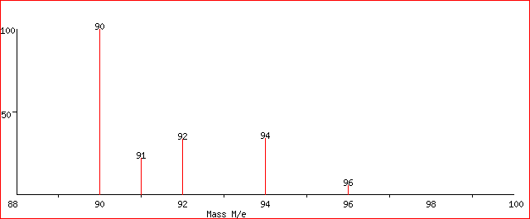

- The mass spectrum below represents a mixture of elements. What elements are present? Justify your answer. (Check your answer using the websites listed above.)

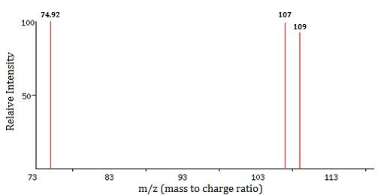

- The mass spectrum of tungsten gives four peaks. Use the data below to answer the following questions:

m/z | 182 | 183 | 184 | 186
Relative intensity | 86.49 | 46.70 | 100.00 | 92.79

  - Sketch the mass spectrum that would be obtained from naturally occurring tungsten.

  - Label each peak on the mass spectrum with the appropriate nuclide symbols.

  - Calculate the average atomic mass of tungsten in the sample rounded to two decimal places.

Conclusions: Now that you’ve learned about mass spectrometry, answer the following questions to summarize the big picture.

- Are all atoms of an element identical and how do we know?

- How can data from mass spectrometry be used to identify the elements and the masses of individual atoms of a specific element.

- How can Data from mass spectrometry also demonstrate direct evidence of different isotopes from the same element?

- How can the average atomic mass be estimated from mass spectra.

- Explain how data from mass spectrometry has advanced our understanding of the atom.

- List and briefly explain any other real world applications of mass spectrometry you can think of?

