Reduction of Organic Compounds Name ____________________
Background: This mechanism is for a LiAlH4 reduction. The mechanism for a NaBH4 reduction is the same except methanol is the proton source used in the second step.
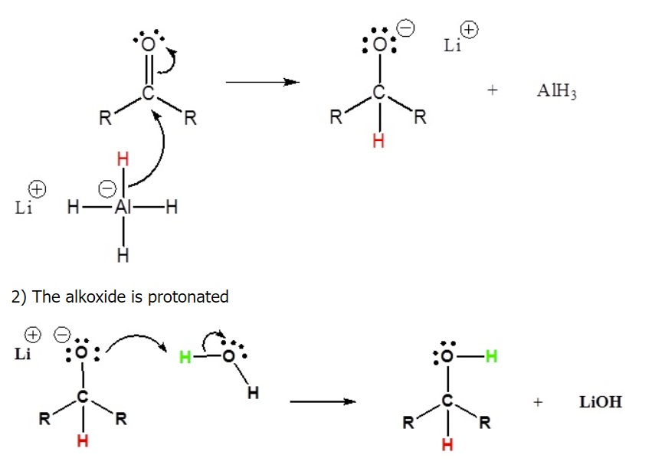
Carboxylic acids can be converted to 1º alcohols using Lithium aluminium hydride (LiAlH₄). Note that NaBH₄ is not strong enough to convert carboxylic acids or esters to alcohols. An aldehyde is produced as an intermediate during this reaction, but it cannot be isolated because it is more reactive than the original carboxylic acid. Esters can be converted to 1º alcohols using LiAlH₄, while sodium borohydride (NaBH₄) is not a strong enough reducing agent to perform this reaction.
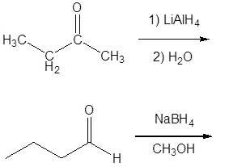
- Draw the products of the following reactions:

- Draw the structure of the molecule which must be reacted to produce the product.
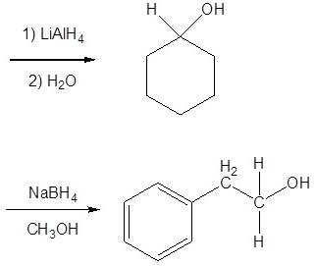

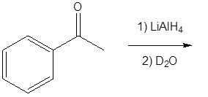
- Deuterium oxide (D₂O) is a form of water where the hydrogens have been replaced by deuteriums. For the following LiAlH₄ reduction the water typically used has been replaced by deuterium oxide. Draw the product of the reaction and place the deuterium in the proper location. Hint! Look at the mechanism of the reaction.

- Give the aldehyde, ketone, or carboxylic acid (there can be multiple answers) that could be reduced to form the following alcohols.
(a) 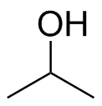 (b) 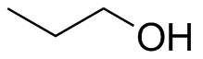
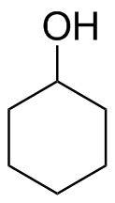
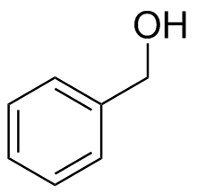
(c) (d)

- Given the following alcohol, draw the structure from which it could be derived using only NaBH₄
(a) 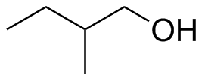 (b) 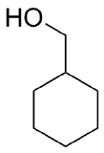
(c) 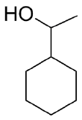 (d) 