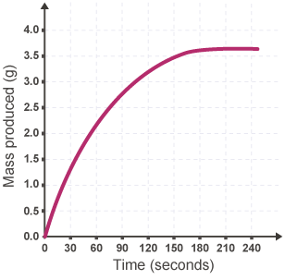
Using Collision Theory to Explain Kinetics Graphs

Q1. Use the graph to answer the following
questions:
- When is this reaction fastest? How does the shape of the graph tell us this?

b) Use Collision Theory to explain why the rate of reaction is fastest at this point.
c) When does this reaction finish? How does the shape of the graph tell us this?
d) How does the shape of the graph show the reaction is slowing down?
e) Use Collision Theory to explain why the rate slows down over time.

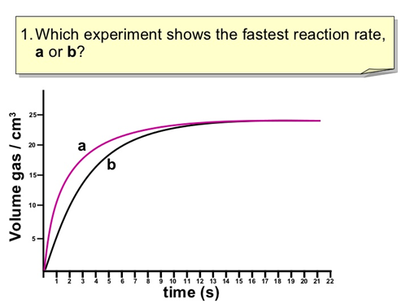

Q2. a) Which experiment shows the reaction with the highest temperature? Use Collision Theory to explain why you have chosen this reaction.

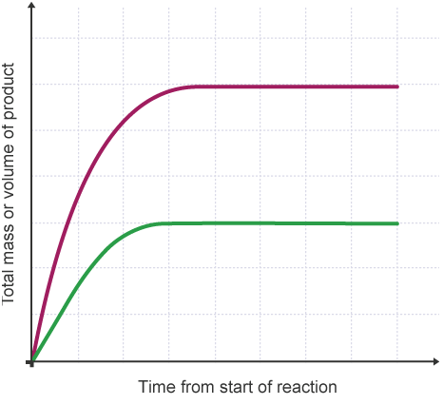
Q3. Two experiments were carried out using an excess of acid and magnesium powder. The top line shows the graph when 2g of Mg was used. What can you deduce about the reaction represented by the lower line?

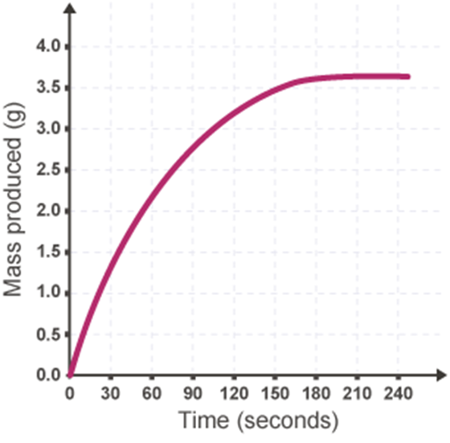
Q4. a) If the graph shows the reaction between excess acid and 5g of carbonate powder, on the same axes sketch the graph for the reaction between excess acid and 5g of carbonate chips. Label this line (A)
b) Sketch another line showing the graph for 2.5g of carbonate powder at a much higher temperature. Label this line (B)

