More Practice Determining Rate Constants Experimentally Name ______________________

- 0.5 g of magnesium reacts with 50 cm³ of 0.01 moldm⁻³ nitric acid. Magnesium is in excess. A graph monitoring the volume of hydrogen gas produced is shown below:

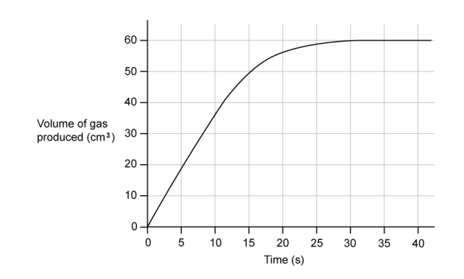
(i) Calculate the mean rate of the reaction over the first 15 seconds of the reaction [1]

(ii) Calculate the actual rate of the reaction at 15 seconds [3]

(iii) Explain the difference in values for the rate [1]

(b) Compare the expected rate and progress of the reaction if 25 cm³ of 0.2 mol dm⁻³ nitric acid was used instead of 50 cm³ of 0.1 mol dm nitric acid. [3 marks]

(c) Suggest one change to the reaction that could be made to produce more hydrogen gas in total and explain your choice. [2 marks]

(d) Suggest why it is often better to study a slower reaction instead of a faster one. [2 marks]

2. An investigation into the rate of the reaction between hydrogen and iodine was carried out at 298 K and the data obtained is shown below.
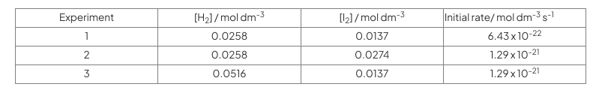
- Determine the rate equation forthe reaction and justify your answer. [3 marks]

(b) Calculate the rate constant using Expt 2 data, including its units. [1 mark]

