Measuring Reaction Rates Using Spectrophotometry Name _______________
(Data taken from the following article)

Introduction:
Methylene blue is a dye that can be used as both an acid-base and redox indicator (as well as medication to treat methemoglobinemia). When oxidized, it is a bright blue color, but turns colorless when reduced. The reaction is shown in (a), along with a copper catalyst. The absorption spectra for the reduction of methylene blue at 664 nm over time is shown in (b). Figure (c) shows the decrease in concentration of oxidized methylene blue over time using different metal catalysts. Figure (d) shows the reduction of oxidized methylene blue over time in different water from different sources (DI water, sea water, tap water, and Saricay water (fresh, creek water)). This indicated how reduction of methylene blue was affected by different water conductivities, as different water sources had different levels of ions within them.
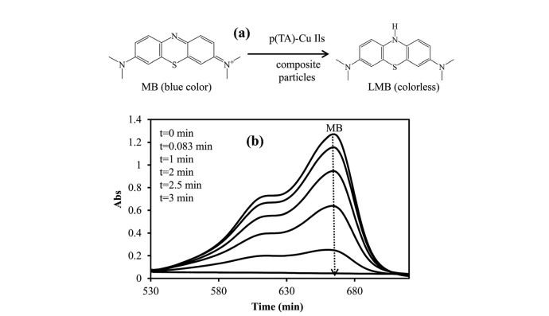
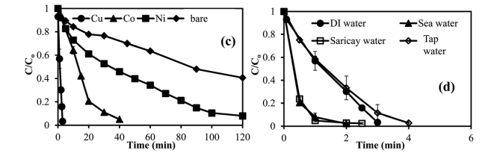
- Looking at the reaction shown in (a), describe the differences between the oxidized and reduced form of methylene blue.


- Graph the absorbance of oxidized methylene blue at 664 nm vs. time.

- What conclusions can you draw from the graph in #2?

- Summarize the data shown in figure (c). How does the type of metal catalyst affect the rate of reduction of methylene blue?

- Given the data shown in figure (d), how does salinity affect the rate of methylene blue reduction? Propose an explanation for this data.

