Determining Reaction Rates Name ________________________

- Use the data provided to calculate the mean rate at the time indicated for the following reaction:
2H₂O₂ (aq) → 2H₂O (l) + O₂ (g)

Time (± 1 sec) | Concentration (mol dm⁻³)
0 | 1.00
120 | 0.91
300 | 0.78
600 | 0.59
1200 | 0.37
1800 | 0.22
2400 | 0.13
3000 | 0.082
3600 | 0.050

- Calculate the mean rate of the decomposition of hydrogen peroxide after 1800 s.

- Calculate the mean rate of decomposition between 2400 s and 3600 s.

2. A student is investigating the rate of a reaction between calcium carbonate and hydrochloric acid according to the following equation:
5 g of calcium carbonate was added to an excess of hydrochloric acid and the mass of carbon dioxide gas was measured every 10 s. The results are shown in the following table:
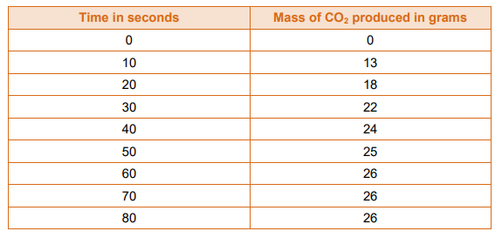

- Plot a graph of the mass of carbon dioxide produced against time.
- Calculate the mean rate of the reaction after 15 s.
- After how many seconds was the reaction finished?

3. A graph showing the reaction between a strip of magnesium ribbon and hydrochloric acid is shown below.

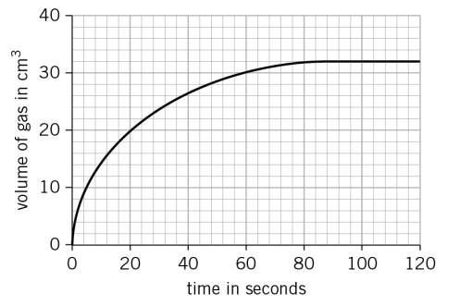
Calculate the rate of the reaction at:
- 20 s
- 40 s
- Show by calculation that the mean rate between 40 s and 60 s is slower than the mean rate between 0 s and 20 s.

4. Zinc reacts with sulfuric acid to produce salt and hydrogen gas. A student is investigating how the size of zinc pieces used affects the rate of the reaction. The student reacts 2.0 g of zinc granules with an excess of sulfuric acid and measures the volume of hydrogen given off.

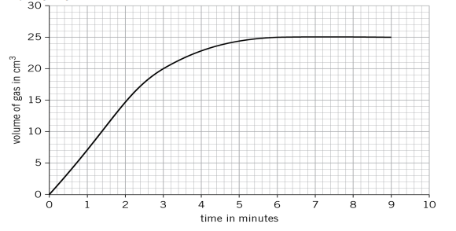

- Name the salt produced in this reaction.
- Calculate the mean rate of the reaction up to the time the reaction is complete.
- Calculate the rate of the reaction at 3 minutes.

The student repeats the experiment using 2.0 g of powdered zinc.

- Sketch a line on the graph to show the results you would expect with the powdered zinc.
- Explain your reasoning behind the line you sketched.

