Designing a Reaction Rate Experiment Name ______________________

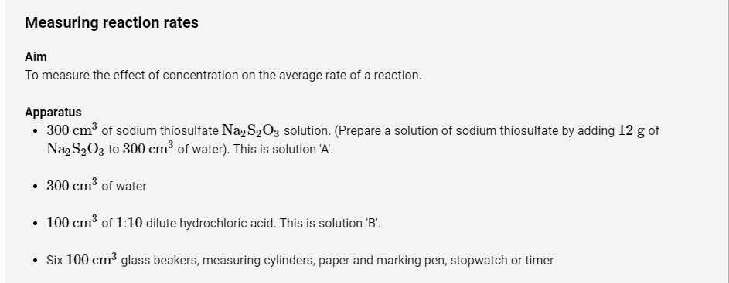
Read the procedure for the following clock reaction:

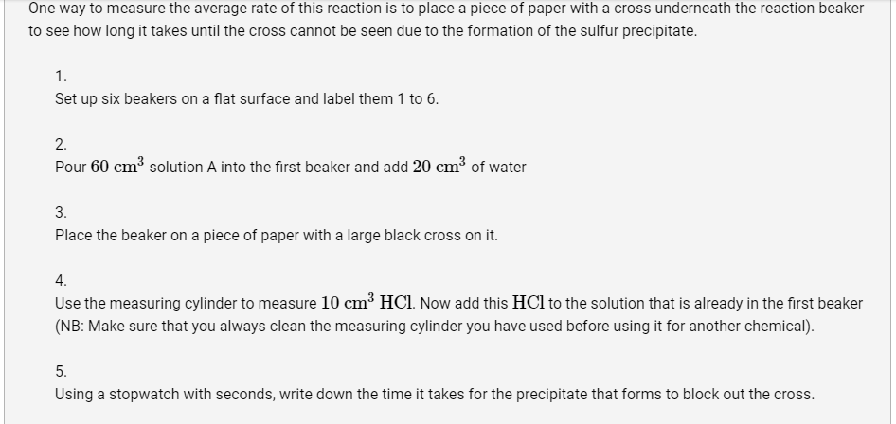
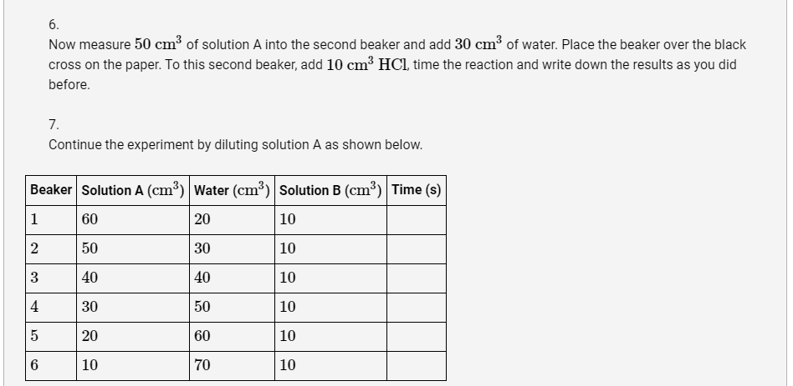

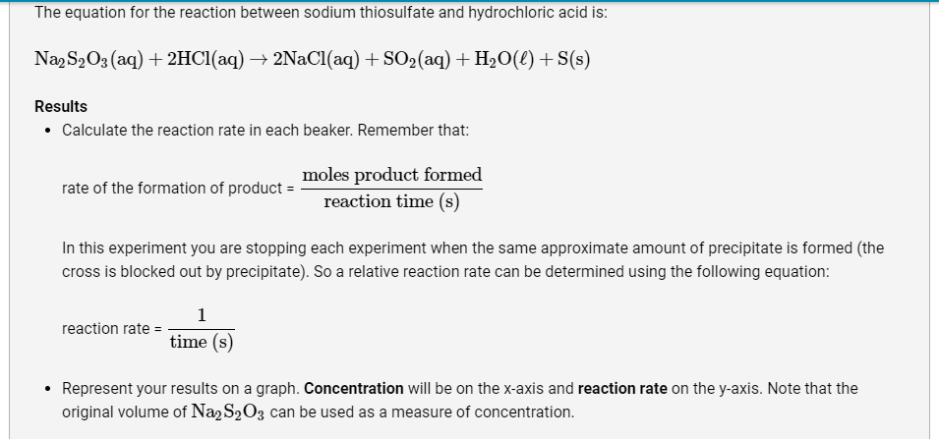

- After reading the procedure and based on your knowledge of kinetics, what can you predict will be the results of this experiment?

- Why is it important to keep the volume of HCl constant?

- Describe the relationship between concentration and reaction rate.

- How could you redesign this experiment to test instantaneous rates rather than average reaction rates (in other words, how can a graph of concentration vs. time be obtained)?

