Model Exploration of Maxwell-Boltzmann Distributions

Model 1 — Graphing Particle Speeds

The diagram below shows a collection of gas particles in a rigid container. The speed of each particle is shown.

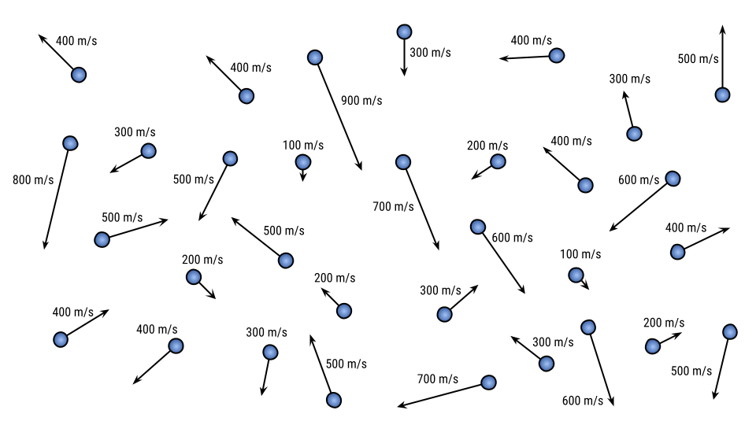

- Create a scatter plot that shows the number of particles moving at each particle speed. Then on top of that graph, make a smooth, curved line graph that starts at the origin and approximately passes through the points. This graph is called a Maxwell-Boltzmann distribution.

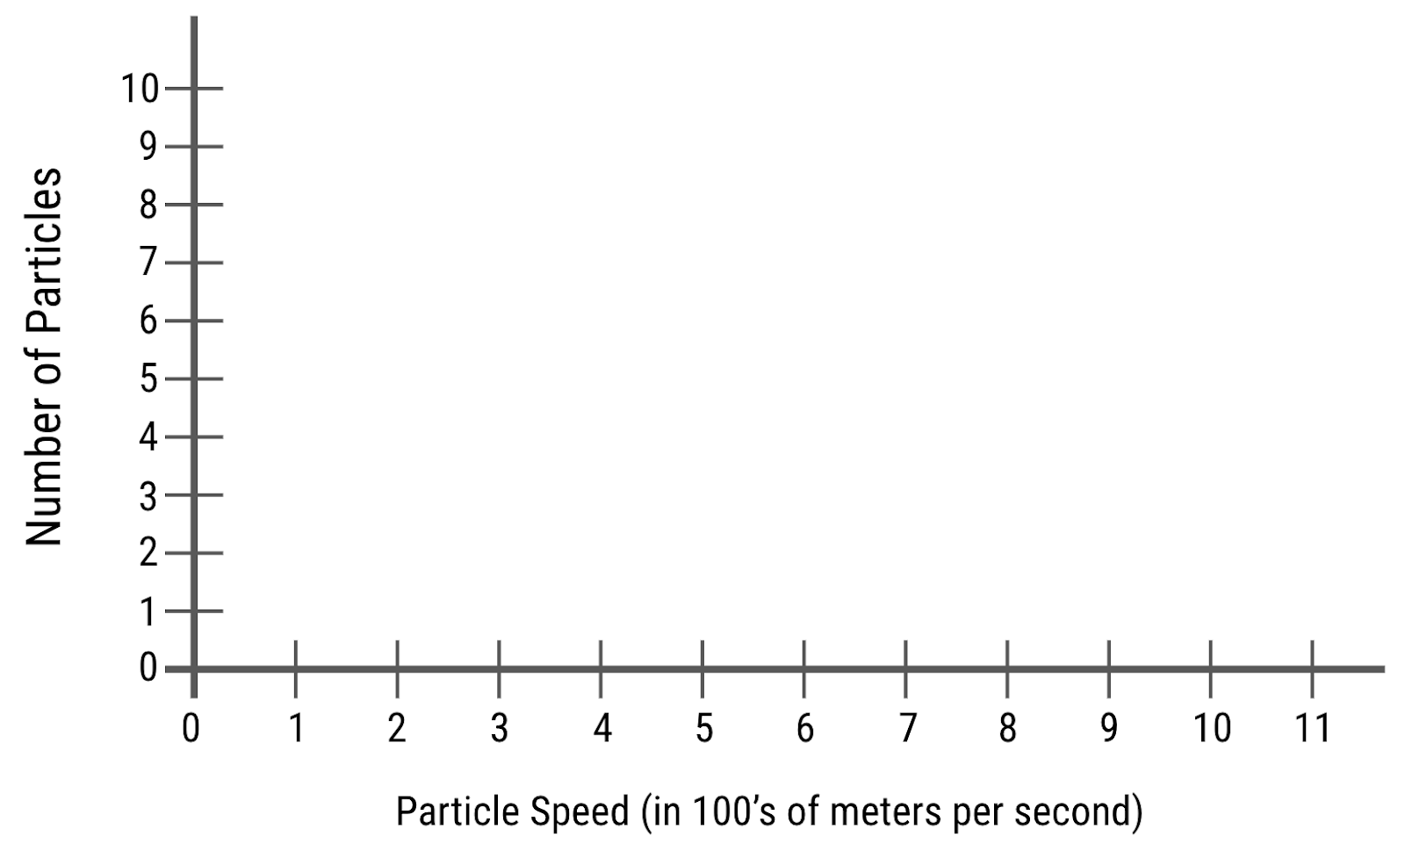

Model 2 — Graphing Particle Speeds at Different Temperatures
Now the sample of particles from Model 1 are heated using a lab burner. Here is a diagram of the particles after being heated.
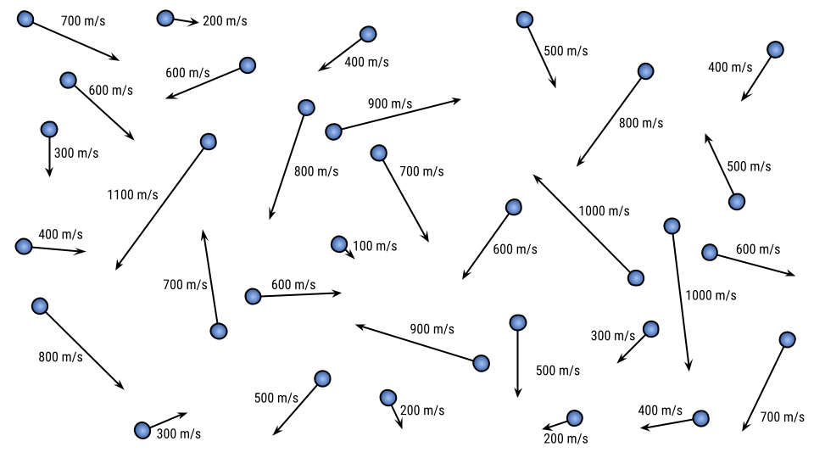
- Create two Maxwell-Boltzmann distributions on the graph below, one for the particles before heating (Model 1) and one for the particles after heating (Model 2). Label the curves “cold” and “hot.”
- What do you notice about the particle speeds after being heated? Also, are there still slow particles?

- What do you notice about how the graph has shifted after heating? What happened to the peak height and location? What is the same about the number of particles?

Model 3 — Graphing Particle Speeds for Particles of Different Mass
Here is another sample of gas particles. Each particle has four times the mass of the blue particles from Model 1. However, the temperature of this sample of particles is actually nearly exactly the same as the particles in Model 1.
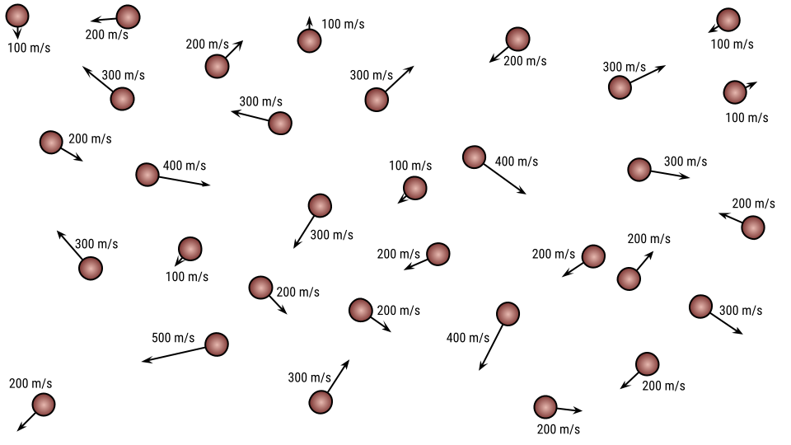

- Keeping in mind that temperature is a measure of the average kinetic energy of a collection of particles, and that KE_{average} = ½ mv², explain how these particles could have the same temperature of the particles in Model 1 even though their speeds are much slower.

- Create two Maxwell-Boltzmann distributions on the graph below, one for the less-massive particles (Model 1) and one for the more-massive particles (Model 3). Label the curves “less massive” and “more massive.”
(Note that the vertical scale has changed on this graph.)
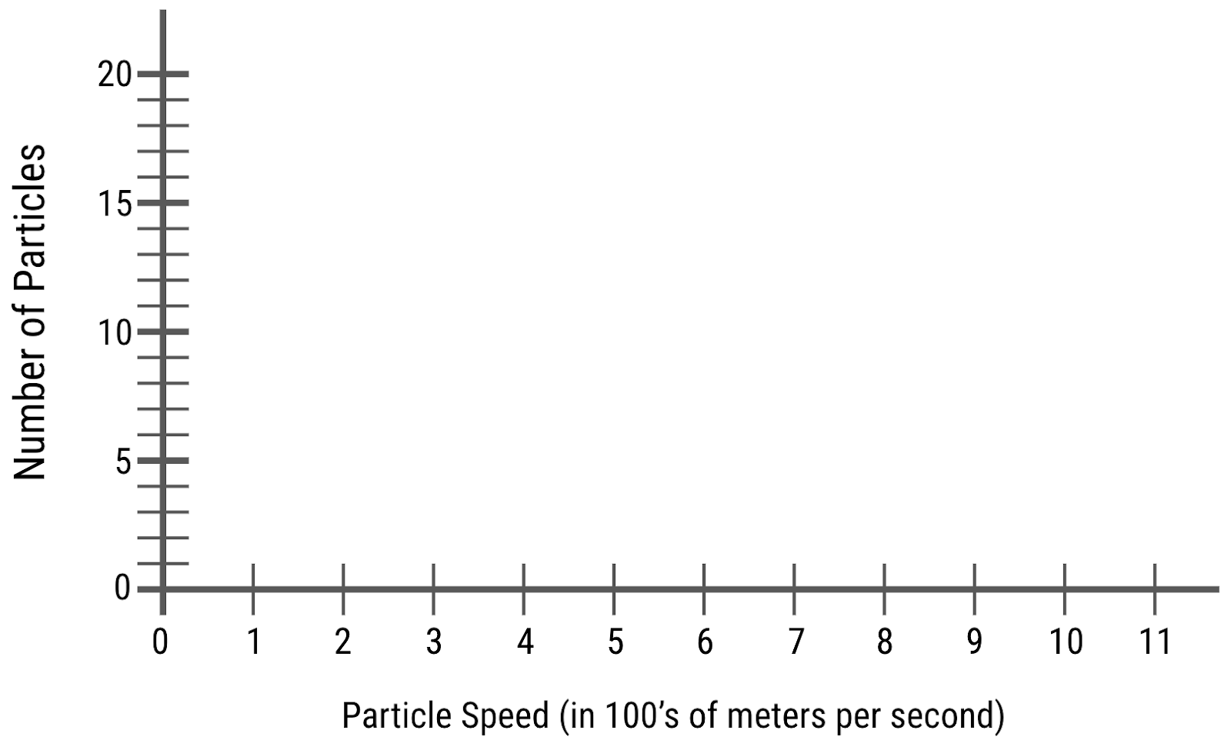

Model 4 — Verify these patterns using the PhET Gas Properties simulation

Open the PhET Gas Properties Simulation. Click the “Energy” tab. Make sure the Kinetic Energy and Speed graphs are open and that the red and blue particle boxes are checked under each graph.
- Do three pumps of large blue particles and three pumps of small red particles. Observe the movement of the particles and the results of both graphs. You may use the table or space below it to record your observations.

 | observations | temperature | speed graph | kinetic energy graph
large blue particles
small red particles

- Now uncheck the blue and red boxes under each graph. Heat the particles way up and observe what happens to the graphs. Then cool the particles way down and observe what happens to the graphs.

observations
when heated
when cooled

