IB Chemistry HL: Rate Laws and Reaction Kinetics Revision Assignment
Name ______________________________________

Part 1: Definitions and Concepts
- Define the following terms in your own words:
  - Rate law:
  - Order of reaction:
  - Rate constant (k):
- Explain the relationship between the rate of reaction and the rate constant (k). How does a change in temperature affect k and why?

Part 2: Multiple Choice Questions
- For the reaction A+2B→C, the rate law is found to be rate=k[A]²[B]⁰. What is the overall order of the reaction?
a) 0
b) 1
c) 2
d) 3
- Which of the following would change the value of the rate constant (k) for a given reaction?
a) Increasing the concentration of a reactant.
b) Increasing the temperature.
c) Adding a catalyst.
d) Both b and c.
- The units of the rate constant (k) for a first-order reaction are:
a) mol dm⁻³ s⁻¹
b) s⁻¹
c) dm³ mol⁻¹ s⁻¹
d) mol⁻¹ s⁻¹

Part 3: Graphical Analysis
- Sketch the following graphs for a first-order reaction:
a) [Concentration] vs. Time:
b) Rate vs. [Concentration]:
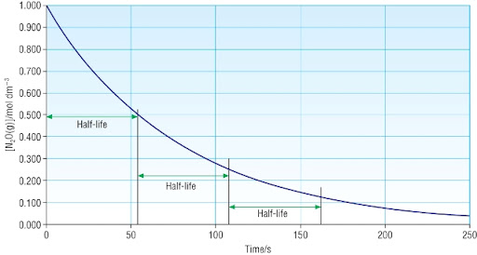
- Examine the graph below, which shows the concentration of a reactant over time.

- a) Is this a zero-order, first-order, or second-order reaction? Justify your answer based on the shape of the curve.
b) Use the graph to estimate the half-life (t_{1/2​}) of the reaction. Is the half-life constant? What does this tell you about the order?

Part 4: Data Analysis
Consider the following reaction: 2X+Y→Z.
A series of experiments was conducted at a constant temperature to determine the rate law.
Experiment | Initial [X] (mol dm⁻³) | Initial [Y] (mol dm⁻³) | Initial Rate (mol dm⁻³s⁻¹)
1 | 0.10 | 0.10 | 2.5×10⁻⁴
2 | 0.20 | 0.10 | 1.0×10⁻³
3 | 0.10 | 0.20 | 2.5×10⁻⁴

- Determine the order of the reaction with respect to X. Show your reasoning.
- Determine the order of the reaction with respect to Y. Show your reasoning.
- Write the rate law for the reaction.
- Calculate the value of the rate constant (k), including its correct units.

