Practice with Condensation Polymerization Name ______________________

- In the spaces below, draw the structure of the polyester formed from:

- Ethanediol and propanedioic acid

- Methanediol and butanedioic acid

2. In the space below, draw the structure of the dipeptide formed from two molecules of the amino acid serine.

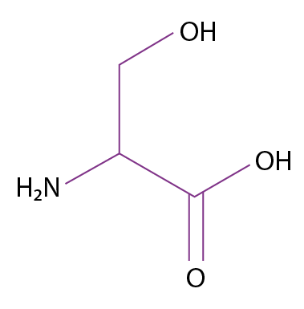

3. Draw the structure of two amino acids that have reacted to make the following dipeptide:
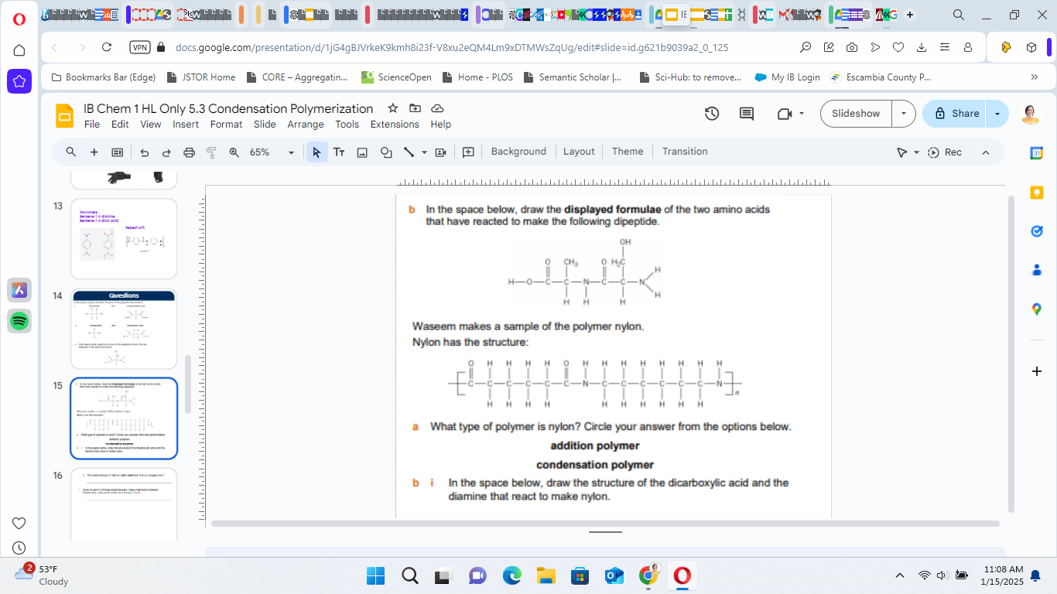

4. Nylon has the structure:

- What type of polymer is nylon?

- Draw the structure of the dicarboxylic acid and the diamine that react to make nylon

