The Haber Process: Industrial Applications of Equilibrium

Introduction
The Haber process, developed by Fritz Haber in the early 20th century, revolutionized agriculture and fundamentally changed the global food system. This industrial process synthesizes ammonia (NH₃) from nitrogen and hydrogen gases, providing the foundation for modern fertilizer production. Your task is to analyze this process through the lens of chemical equilibrium principles.
The Haber Process Reaction: N₂(g) + 3H₂(g) ⇌ 2NH₃(g) ΔH = -92 kJ mol⁻¹

Question 1 (8 marks)
The Haber process operates under specific industrial conditions: approximately 450°C temperature, 200-300 atm pressure, and uses an iron catalyst.
a) Using Le Chatelier's Principle, explain why high pressure favors ammonia production. Include a quantitative analysis of the gas molecules involved. (3 marks)
b) The reaction is exothermic (ΔH = -92 kJ mol⁻¹). Explain why industrial plants use temperatures around 450°C rather than much lower temperatures that would theoretically favor ammonia formation. (3 marks)
c) Describe the role of the iron catalyst and explain why it doesn't affect the equilibrium position. (2 marks)

Question 2 (9 marks)
At 500°C, the equilibrium constant Kc for the Haber process is 6.0 × 10⁻² mol⁻² dm⁶.
a) Write the expression for Kc for this reaction. (2 marks)
b) In an industrial reactor at 500°C, the equilibrium concentrations are found to be:
- [N₂] = 1.50 mol dm⁻³
- [H₂] = 2.25 mol dm⁻³
- [NH₃] = 0.825 mol dm⁻³
Verify that these concentrations represent an equilibrium state by calculating K_{c}. (4 marks)
c) If the reactor conditions are suddenly changed so that:
- [N₂] = 2.00 mol dm⁻³
- [H₂] = 3.00 mol dm⁻³
- [NH₃] = 0.50 mol dm⁻³
Calculate the reaction quotient (Q_{c}) and predict the direction of the reaction to reach equilibrium. Show all working. (3 marks)

Question 3 (8 marks)
Consider how changes in conditions affect the equilibrium position:
a) If ammonia is continuously removed from the reactor during the process, use Le Chatelier's Principle to explain how this affects the equilibrium and overall yield. (3 marks)
b) Compare the equilibrium constant values at two different temperatures:
- At 400°C: K_{c} = 4.1 × 10⁻¹ mol⁻² dm⁶
- At 500°C: K_{c} = 6.0 × 10⁻² mol⁻² dm⁶
Explain what this tells you about the relationship between temperature and equilibrium position for this reaction. (3 marks)
c) Industrial plants typically achieve only 10-20% conversion of reactants to products per pass through the reactor. Suggest why this low conversion rate is economically acceptable. (2 marks)

Question 4 (7 marks)
The Haber process represents a classic example of industrial compromise between theoretical ideal conditions and practical limitations.
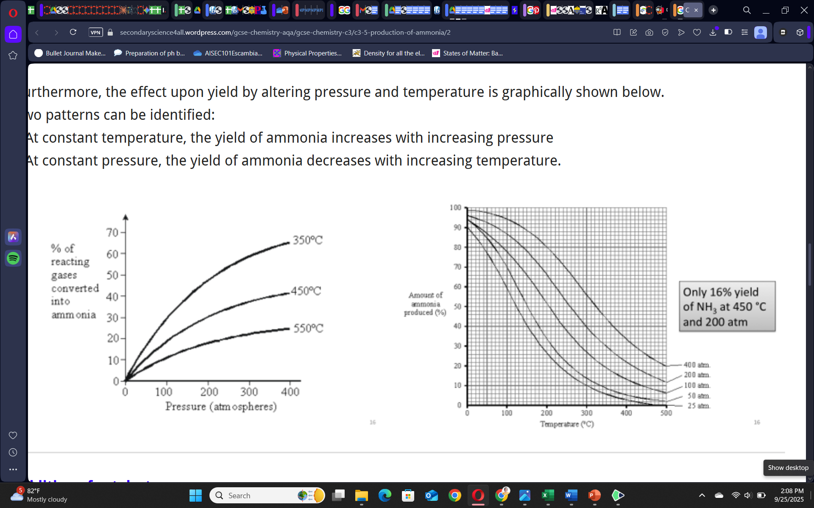
a) Create a table comparing the theoretically optimal conditions (based purely on equilibrium considerations) versus the actual industrial conditions used. Include temperature, pressure, and catalyst for each. (4 marks)

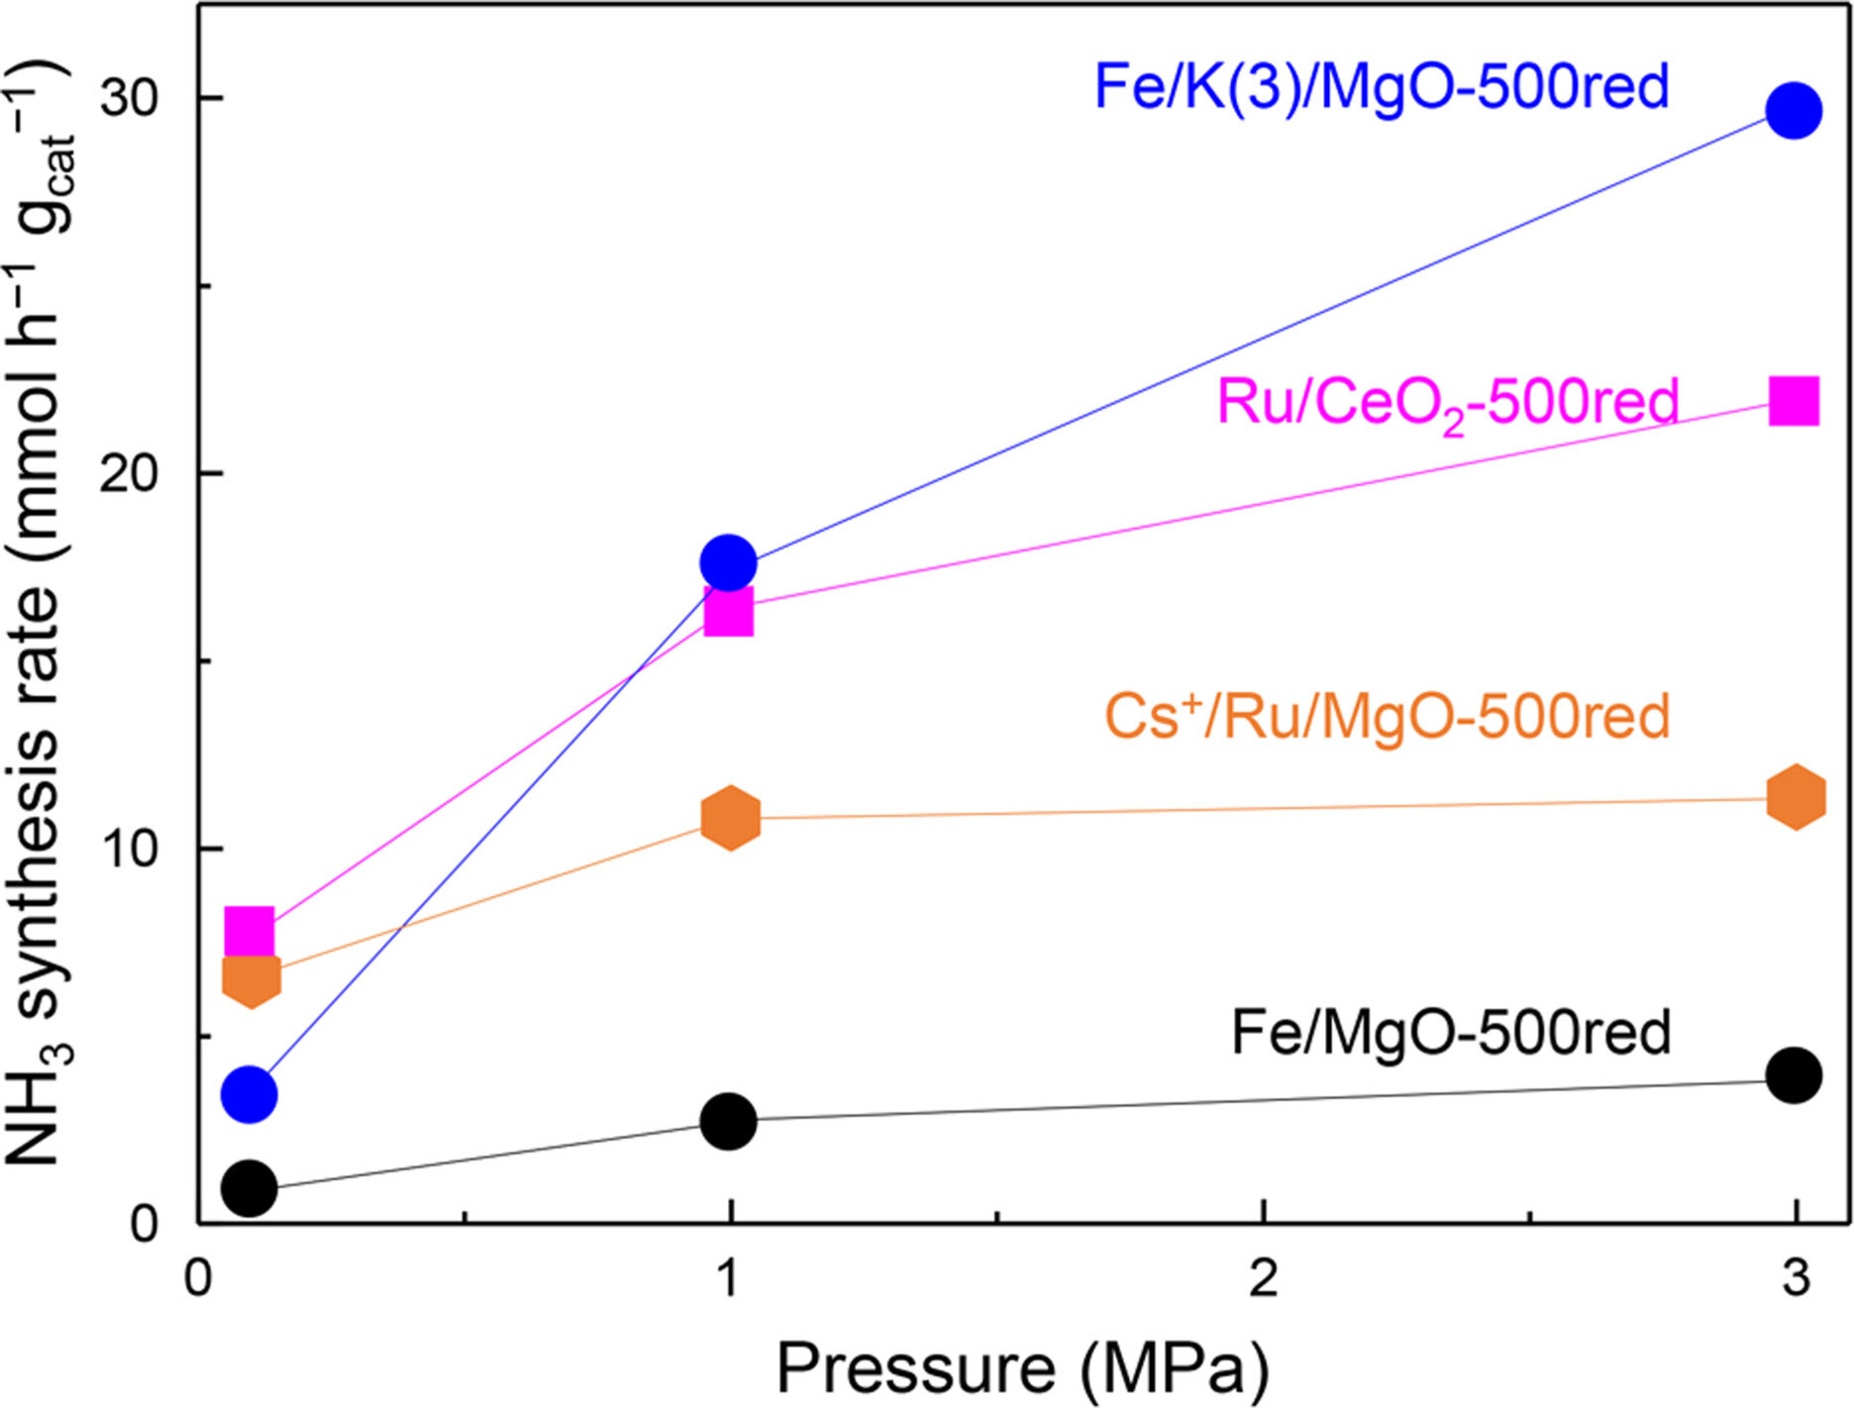
b) For each difference identified, explain the practical reason why industrial plants don't use the theoretically optimal conditions. (3 marks)

Question 5 (8 marks)
Research the economic and environmental aspects of the Haber process.
a) The Haber process consumes approximately 1-2% of global energy production. Explain why this process requires such enormous energy input, considering both the reaction conditions and the source of hydrogen gas. (4 marks)
b) Discuss two current research directions aimed at making ammonia synthesis more sustainable, and explain how these might relate to equilibrium principles. (4 marks)

Question 6 (10 marks)
Fritz Haber won the Nobel Prize in Chemistry in 1918 for this process, yet his legacy remains controversial.
a) Explain how the Haber process enabled the global population to grow from 1.6 billion in 1900 to over 8 billion today. Include the concept of "fixing" atmospheric nitrogen in your answer. (4 marks)
b) Research and discuss one positive and one negative environmental consequence of widespread ammonia production and use. (4 marks)
c) Some historians argue that the Haber process changed the course of World War I. Research this claim and provide a brief explanation of how chemical equilibrium principles affected global history. (2 marks)

