Relationship Between Rate and Equilibrium Name _______________________
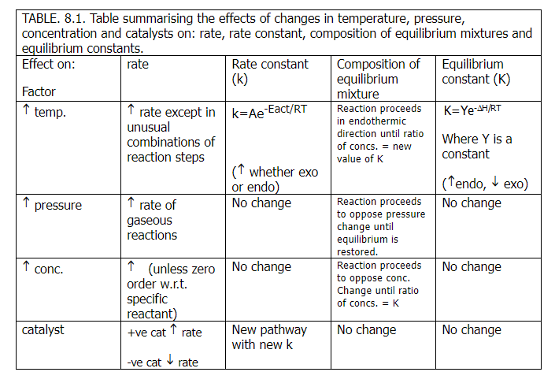
Use the following table as a reference to help answer the questions below:

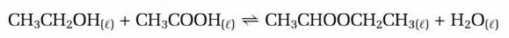
1) For the reaction in aqueous solution between ethanoic acid and ethanol producing ethyl ethanoate:
ΔH>0
i) Write three possible forward rate expressions, assuming the reaction is second order.

ii) What would be the units of the rate constant in each case?

iii) Write the equilibrium expression.

iv) If the reaction is carried out in dilute aqueous solution, write another ratio of concentrations that would remain constant even if more ethanoic acid were added to the system at equilibrium;

v) Describe the difference between rate and rate constant.

vi) Describe the difference between equilibrium and equilibrium constant.

vii) Explain how the composition of the equilibrium mixture remains constant despite the fact that reactions continue to occur.

viii) With reference to the effects on rate and equilibrium, describe what will happen to the ethyl ethanoate concentration when the following changes are made to the system (assuming the reaction is at equilibrium before each change):
a) a small amount of pure ethanoic acid is added;

b) a small amount of water is added;

c) a large amount of water is added;

d) atmospheric pressure increases;

e) a few drops of concentrated sulphuric acid (catalyst) are added;

f) a moderate amount of concentrated sulphuric acid is added;

g) the temperature is increased.

