Reading: Atomic Emission Spectra

Directions: Read the article and answer the questions below.

Original Link
https://www.ck12.org/chemistry/atomic-emission-spectra/lesson/Atomic-Emission-Spectra-CHEM/?referrer=concept_details

How much energy does it take to shoot an arrow?

Archery as a sport or a means of defense has existed for centuries. At rest, there is no tension on the bowstring and no force on the arrow. When the string and arrow are pulled back, we now have a situation where kinetic energy (pulling of the string) has been converted to potential energy (the tension on the string). The archer releases the arrow and the potential energy is translated into kinetic energy as the arrow moves. It turns out that electrons behave the same way.

Atomic Emission Spectra
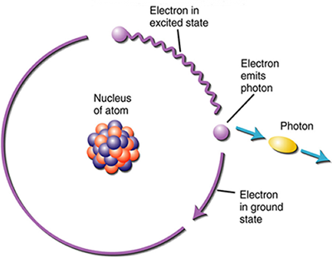
The electrons in an atom tend to be arranged in such a way that the energy of the atom is as low as possible. The ground state of an atom is the lowest energy state of the atom. When those atoms are given energy, the electrons absorb the energy and move to a higher energy level. These energy levels of the electrons in atoms are quantized, meaning again that the electron must move from one energy level to another in discrete steps rather than continuously. An excited state of an atom is a state where its potential energy is higher than the ground state. An atom in the excited state is not stable. When it returns back to the ground state, it releases the energy that it had previously gained in the form of electromagnetic radiation.

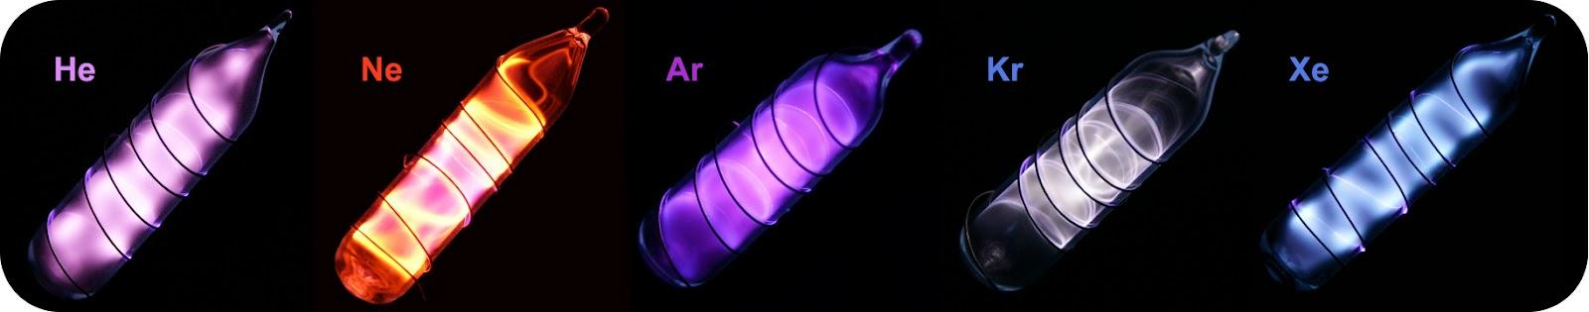
Gas discharge tubes are enclosed glass tubes filled with a gas at low pressure through which an electric current is passed. Electrons in the gaseous atoms first become excited, and then fall back to lower energy levels, emitting light of a distinctive color in the process. Shown are gas discharge tubes of helium, neon, argon, krypton, and xenon.

Scientists studied the distinctive pink color of the gas discharge created by hydrogen gas. When a narrow beam of this light was viewed through a prism, the light was separated into four lines of very specific wavelengths and frequencies. Just like a rainbow shows us the spectrum of colors, scientists can study the light of stars. This study is called spectroscopy. An atomic emission spectrum is the pattern of lines formed when light passes through a prism to separate it into the different frequencies of light it contains. The figure below shows the atomic emission spectrum of hydrogen.

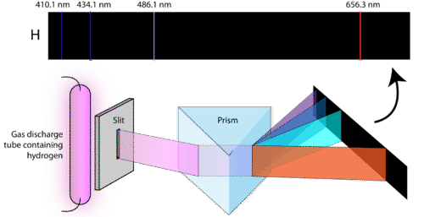

When light from a hydrogen gas tube is passed through a prism, the light is split into four visible lines. Each of these spectral lines corresponds to a different electron transition from a higher energy state to a lower energy state. Every element has a unique atomic emission spectrum.

Article Questions
- Explain the difference between a ground state and an excited state of an atom.
- How is the movement of electrons in an atom similar to archery?
- What is an atomic emission spectra?
- Look again at the gas tubes diagram and the Hydrogen prism diagram. Why is each element’s atomic emission spectra unique?

Part 2: Interactive LINK: https://www.ck12.org/chemistry/atomic-emission-spectra/lesson/Atomic-Emission-Spectra-CHEM/?referrer=concept_details
*Once you open the link, the interactive is towards the bottom and looks like this graphic:
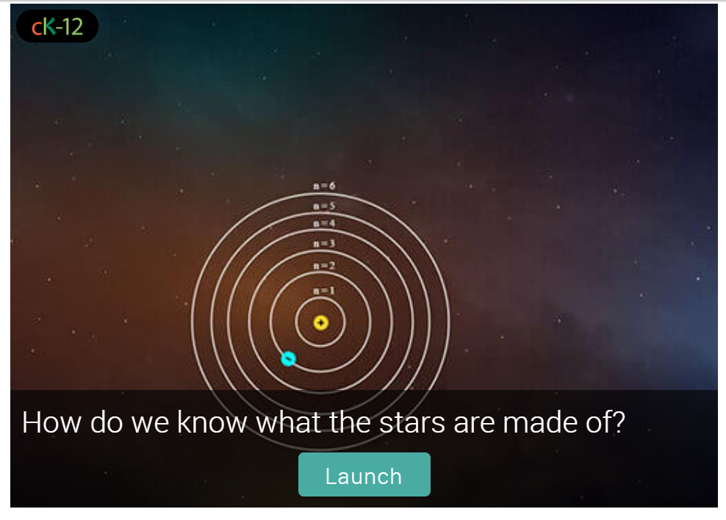

Background: How do we know what stars are made of?

Astronomers know a great deal about the composition of the planets and stars in the universe. For Instance, it is known that the universe consists primarily of hydrogen and helium. How could we know such details? Are the elements the same on Earth as they are in a distant galaxy? How would we know that? Let's Investigate the physics behind this. In the model of the atom popularized by Niels Bohr in the early 20th century, electrons orbit the atomic nucleus in a variety of orbital paths. Paths with greater radius are at higher energy. When an electron absorbs light energy with just the right color, it can jump up an energy level. A hot, dense source of light, like the interior of a star, produces colors of all types. If a thin cloud of atoms - like the atmosphere of the star itself - gets in the way, then it absorbs light at specific colors. We Call this an absorption spectrum. These colors are unique to the atom in question - hydrogen absorbs different colors than helium. The spectrum of each element is different. By looking at distant objects with a telescope, we can see which colors are missing in absorption - this tells us what atoms are present! Let's Investigate!

**Before you answer the questions, play around with the simulation first. It will hopefully help you answer the questions easier.

- Look at the graph of wavelength and intensity. What variable is on the x-axis? What variable is on the y-axis?

- At the bottom of the interactive, you can change the type of graph you see (emission, absorption and continuous) with a slide bar. Describe the difference between an emission spectrum and an absorption spectrum.

- When looking at the peaks of the emission spectrum and the dips of the absorption spectrum, how are they related to the wavelength of light on the color spectrum?

- An electron interacts with a violet photon (410 nm) and jumps from the n = 2 to the n = 6 energy level as a result. What type of element was involved, and what type of interaction occurred?

- An electron interacts with light blue/cyan-colored light (486 nm) and jumps from the n = 4 to the n =2 energy level as a result. Which element was involved, and what type of interaction occurred?

