Melting and Boiling Points of Ionic Compounds Name _________________
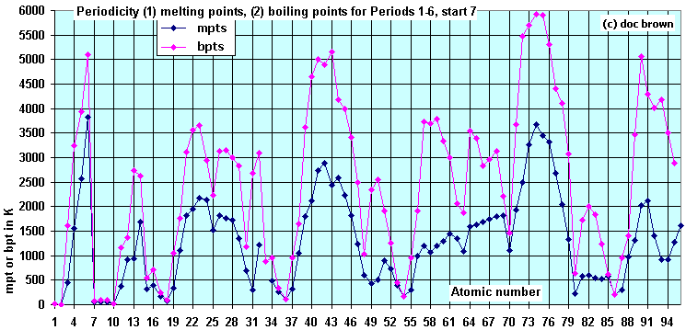

- Based on the graph, make another graph, only containing Group 1 melting and boiling points.

- Do the same as described in question 1, only do this for Group 2 elements.

- Based on the graphs in questions 1 and 2, what are the general trends in melting and boiling points down group 1 and group 2? Explain your reasoning.

- Do any group 1 and group 2 elements “break” the trend? If so, explain why this occurs.

