Chromatography Case study
While you were completing the most recent Chemistry test, the teacher had to leave the room for a moment. During this time, you saw two other students swap exam papers and continue writing on each other's tests. Your teacher is suspicious of the grades one of these students achieved and is offering a reward if any student can prove that cheating occurred. The teacher suspects that three other students may have been involved in the incident and collected the pens used by all students to write the tests. Answer the questions to show whether cheating happened and to make sure the teacher knows you were not involved!
The figure below shows the chromatogram the teacher obtained when testing the students’ pens.
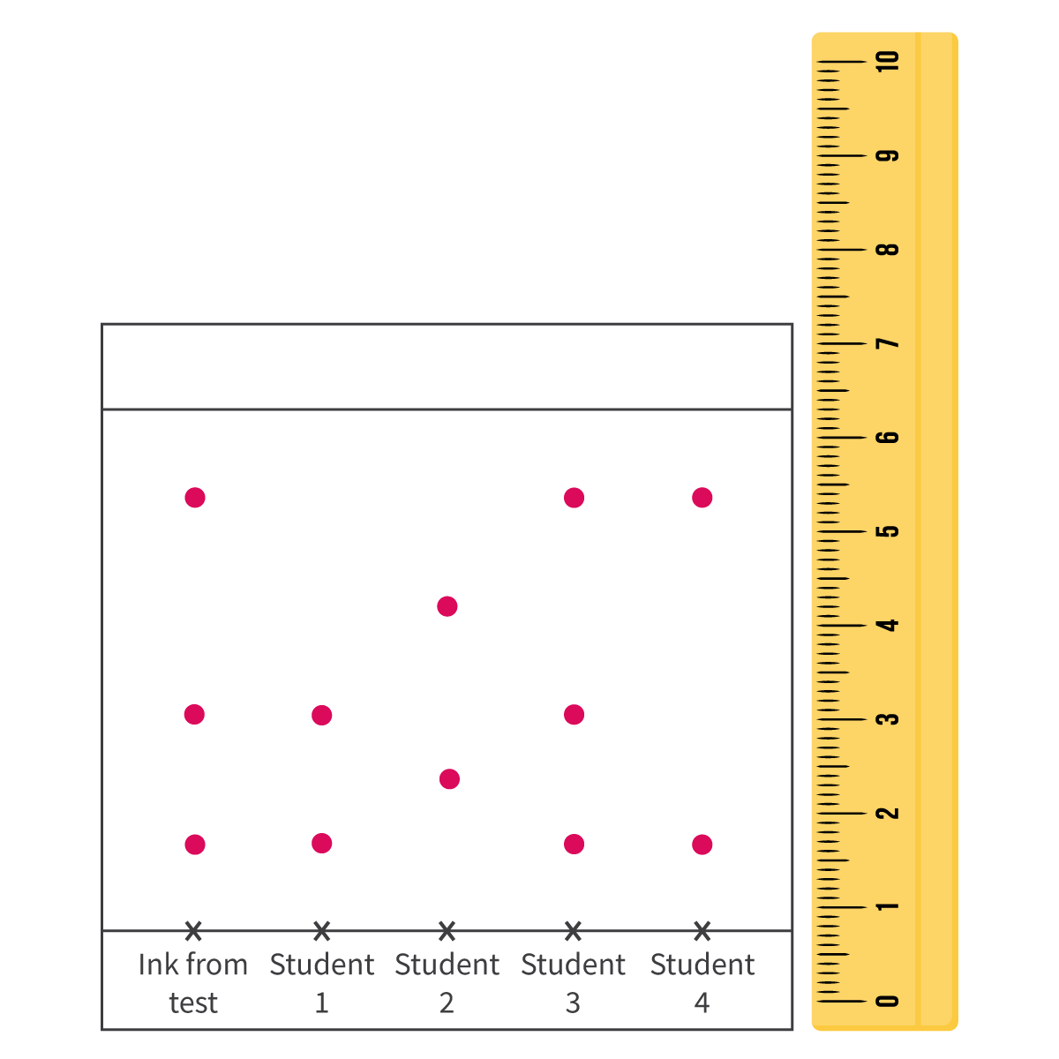
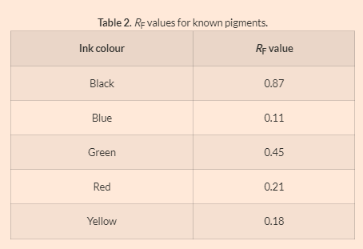
- Describe how the chromatogram could be attained by the teacher.
- Identify how many different dyes were in the ink from the test?
- Identify which student's pen was definitely not used to cheat on the test. Justify your choice.
- Suggest which student was involved in the cheating. Justify your choice.
- When doing chromatography, it is important that the line on which the pens are all placed at the beginning is drawn in pencil and not pen. Explain why this is using your knowledge of intermolecular forces that was presented in this section.
- The inks from the suspects pens were compared to a table to known pigments commonly present in pens, shown in Table 2. Identify which inks were present in the pen used to write the test. Outline why comparing the values obtained by the teacher against the values obtained from a different chromatogram is valid.

