Formal Charge and Resonance NAME:

Formal charge is an accounting procedure. It allows chemists to determine the location of charge in a molecule as well as compare how good a Lewis structure might be. The formula for calculating formal charge is shown below:

Formal Charge = # valence e⁻ - ( # non-bonding e⁻ + ½ # bonding e⁻ )

Note: the formal charges must add up to the net charge of the molecule; also, like formal charges cannot appear next to each other within the molecule

Ranking the importance of resonance structures:
- Those with an electron count around an atom of at least an octet, barring exceptions, and no charge separation are favored over
- Those that exhibit a charge separation, which are favored over
- Those that exhibit a charge separation against that predicted by electronegativity.
- Summary: Most # of bonds for least formal charges are most important
We can determine which Lewis structure is better by determining which has the least formal charge. It takes energy to get a separation of charge in the molecule (as indicated by the formal charge) so the structure with the least formal charge should be lower in energy and thereby be the better Lewis structure.

Generally, the Lewis structure with the smallest formal charges on individual atoms will be the “best” one.

EXAMPLES

Which of the following is a better Lewis dot structure for carbon dioxide (CO₂)?

Structure A | Structure B
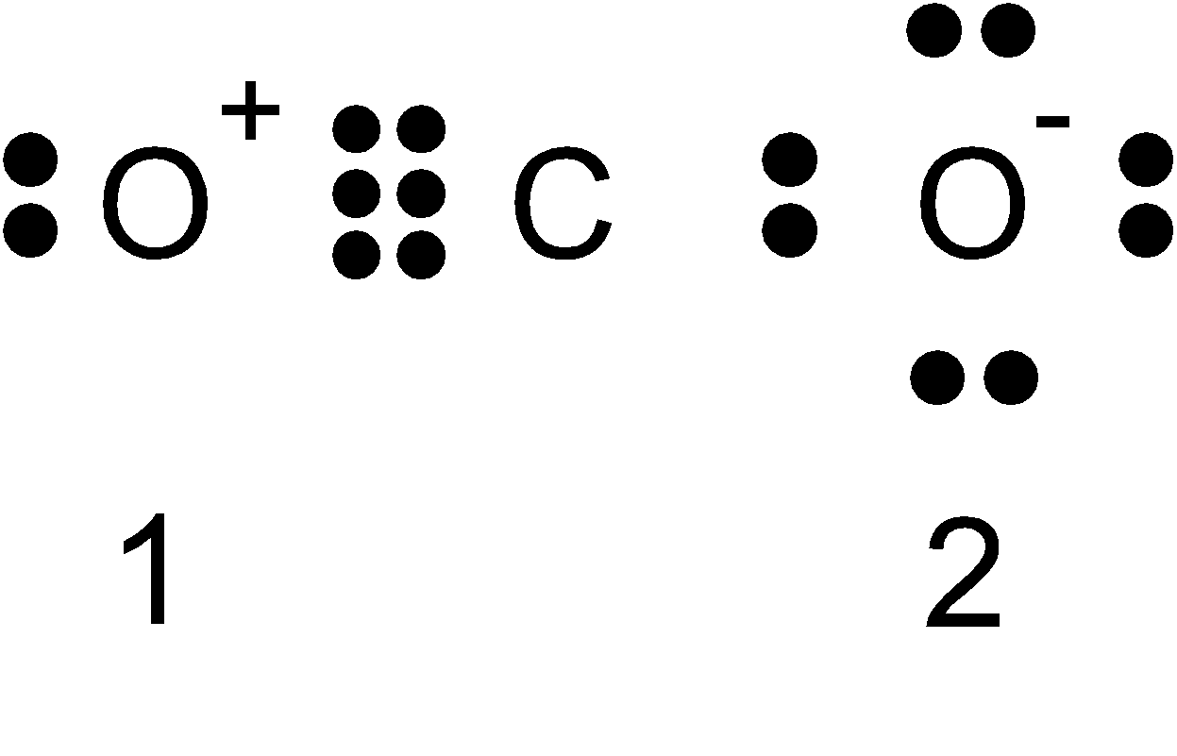 | 

The answer is Structure B because it has the least formal charges even though both structures satisfy all octets and have the correct number of valence electrons.

Calculate the formal charges on all of the atoms in the following molecules:

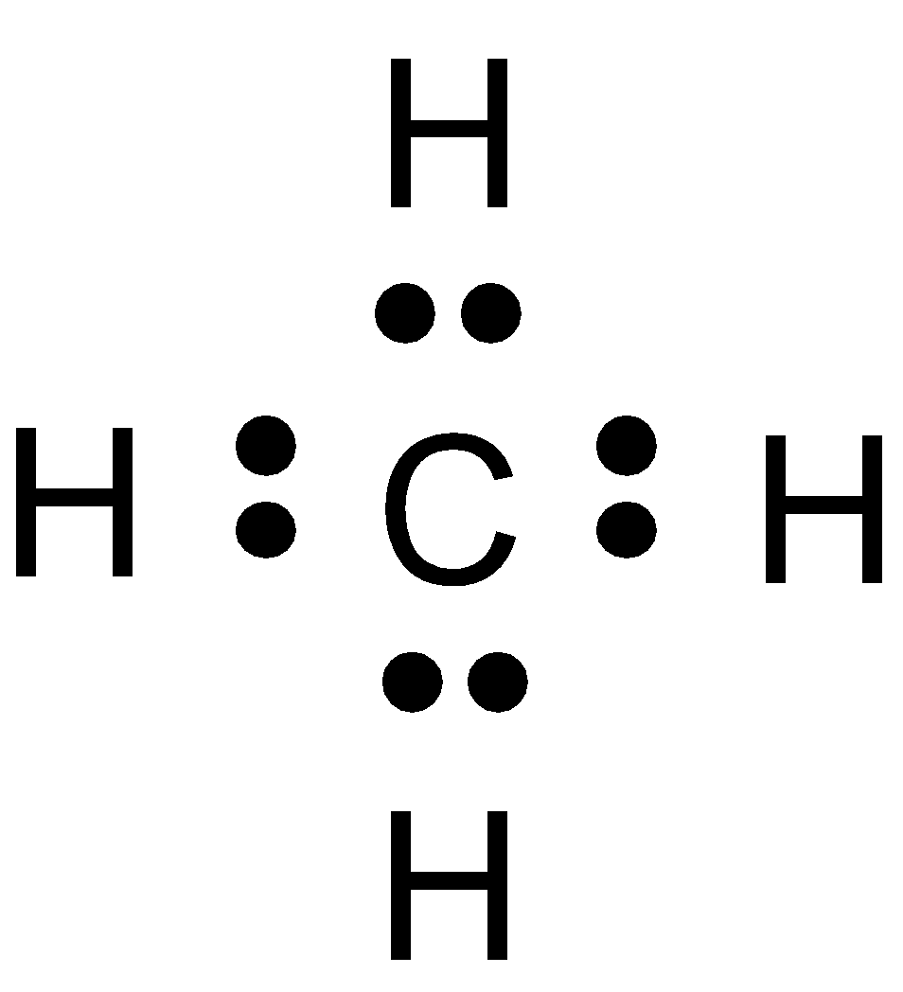 Carbon; FC = 4 – (0 + ½*8) = 0 each H; FC = 1 – (0 + ½ * 2) = 0
The molecule is neutral and has no formal charges

Choose the best structure based on formal charges
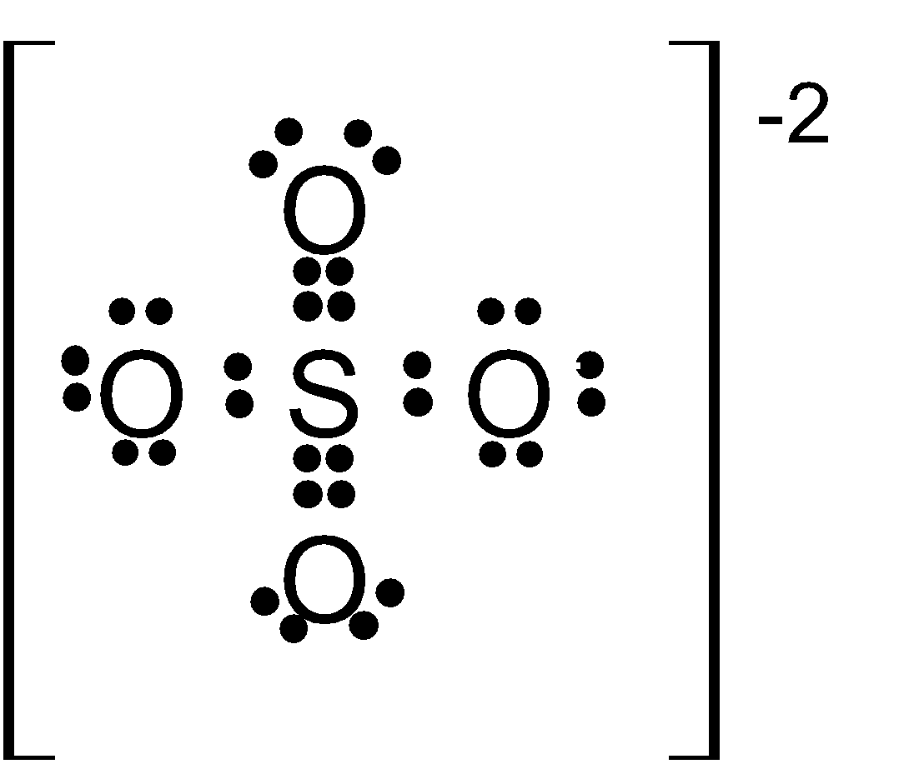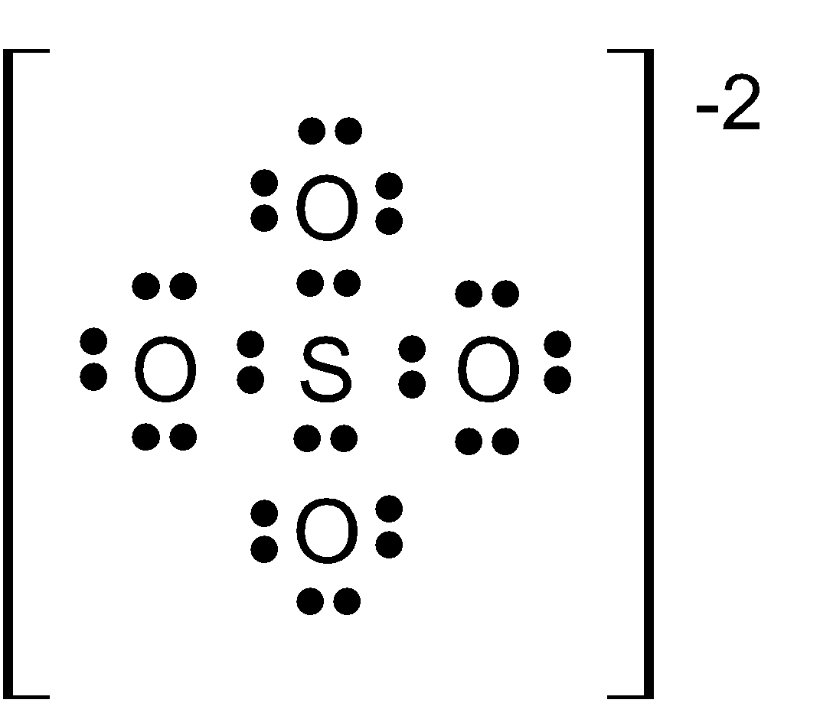
A B

Structure A Structure B
1-Sulfur FC = 6 – (0 + ½*12) = 0 1-Sulfur FC = 6 – (0 + ½*8) = +2
2-Oxygen (double bond) FC = 6 – (4 + ½*4) = 0 4-Oxygen FC = 6 – (6 + ½*2) = -1
2-Oxygen (single bond) FC = 6 – (6 + ½*2) = -1

Net FC = -2 Net FC = -2

So which structure is “better?” While structure A minimizes the formal charges, it violates the Octet rule for sulfur. (We will see why this is OK later.) Also, what makes two of the oxygen atoms more “special” in that they have a double bond while the others are only single bonded? Structure B has formal charges on every atom, and the +2 on sulfur is somewhat large. Could both structures play a role in understanding the true nature of the sulfate ion? I purposely chose a difficult structure that raises these types of questions for you to study and think about. The next topic will address some of these issues.

PROBLEMS

1)Assign formal charges to each atom in the following structures. Show your work.
 | 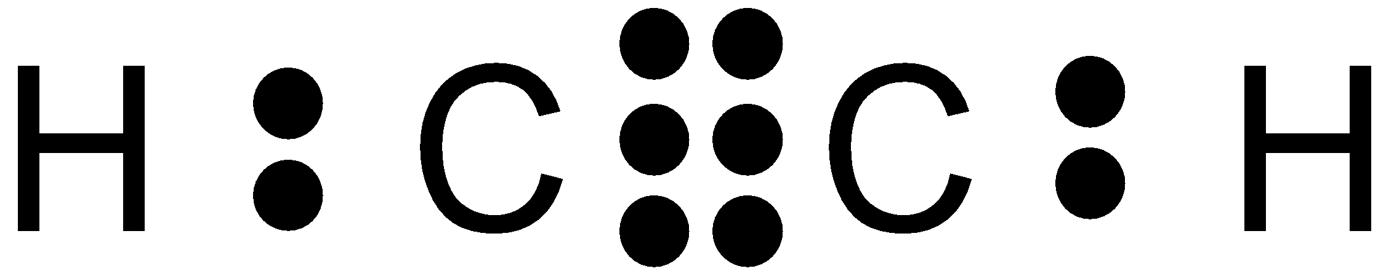 | 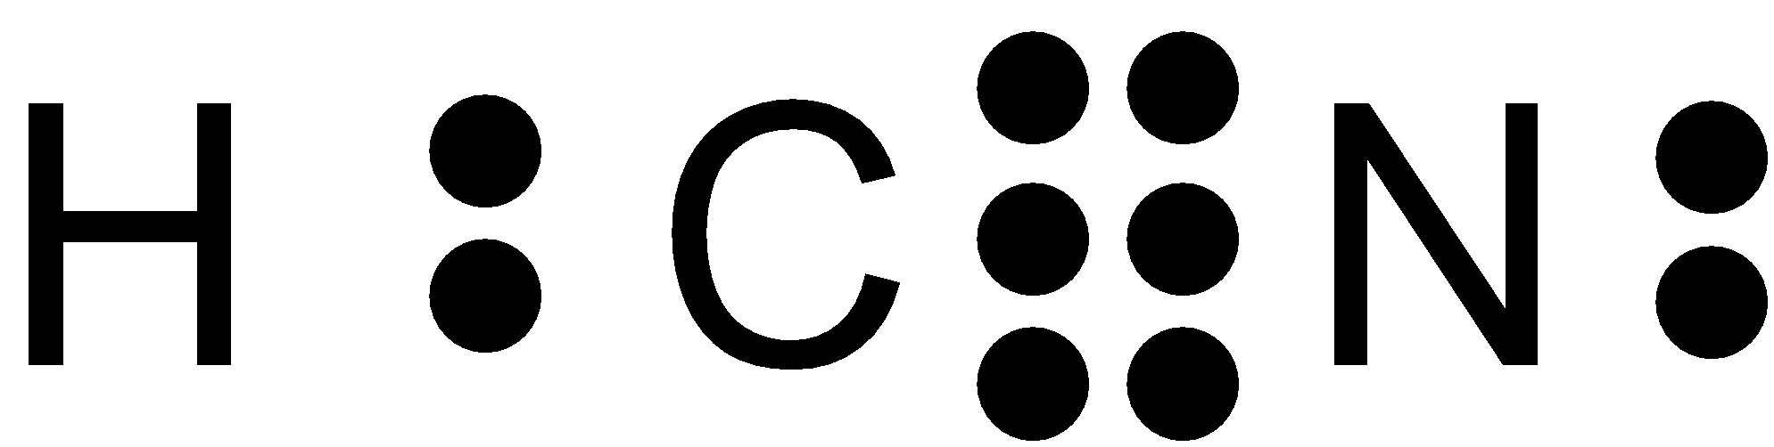 | 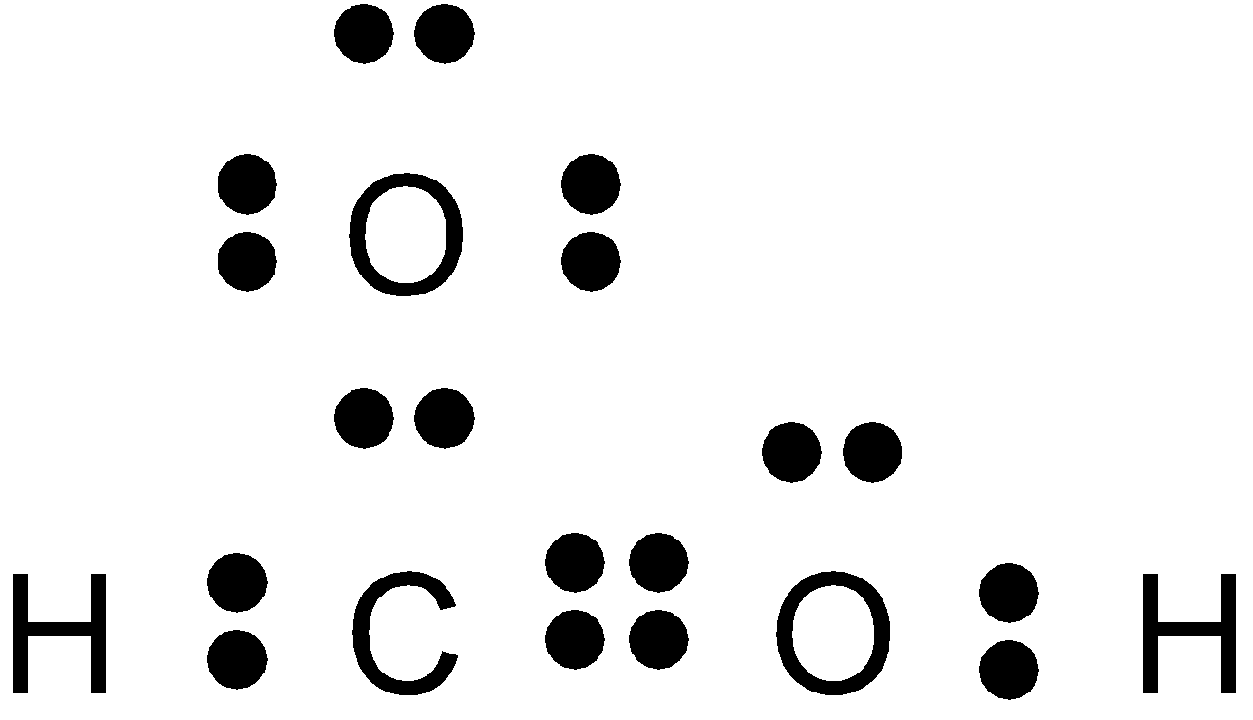
C = | C = | H = | C =
O = | H = | C = | O_{d} =
 |  | N = | O_{s}=
 |  |  | H =

2)Choose the best structure based on formal charges. Show your work and explain.

A) or 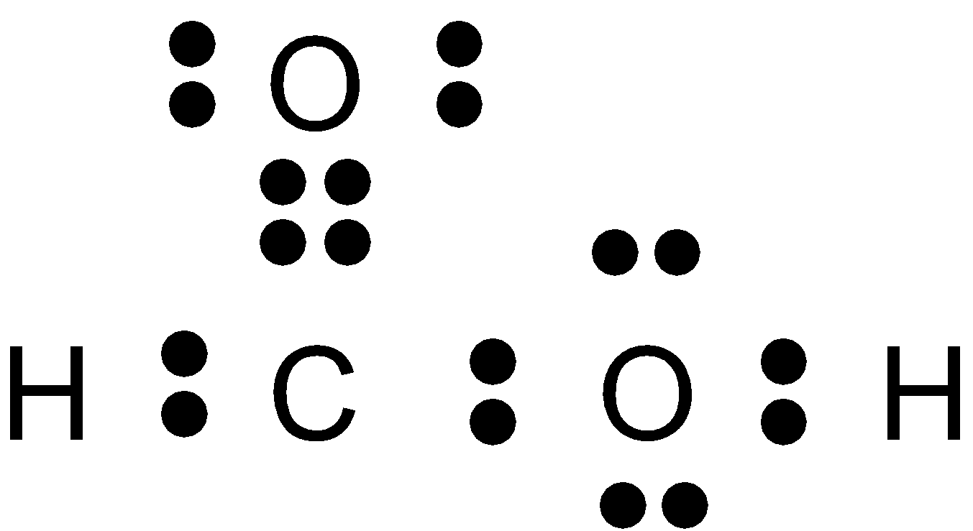

B) 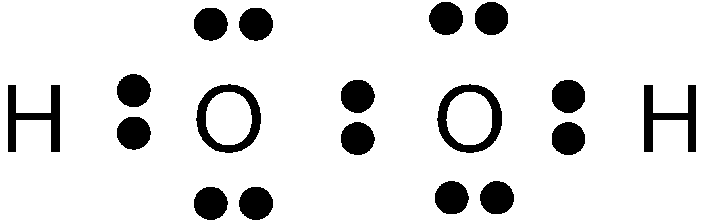 or 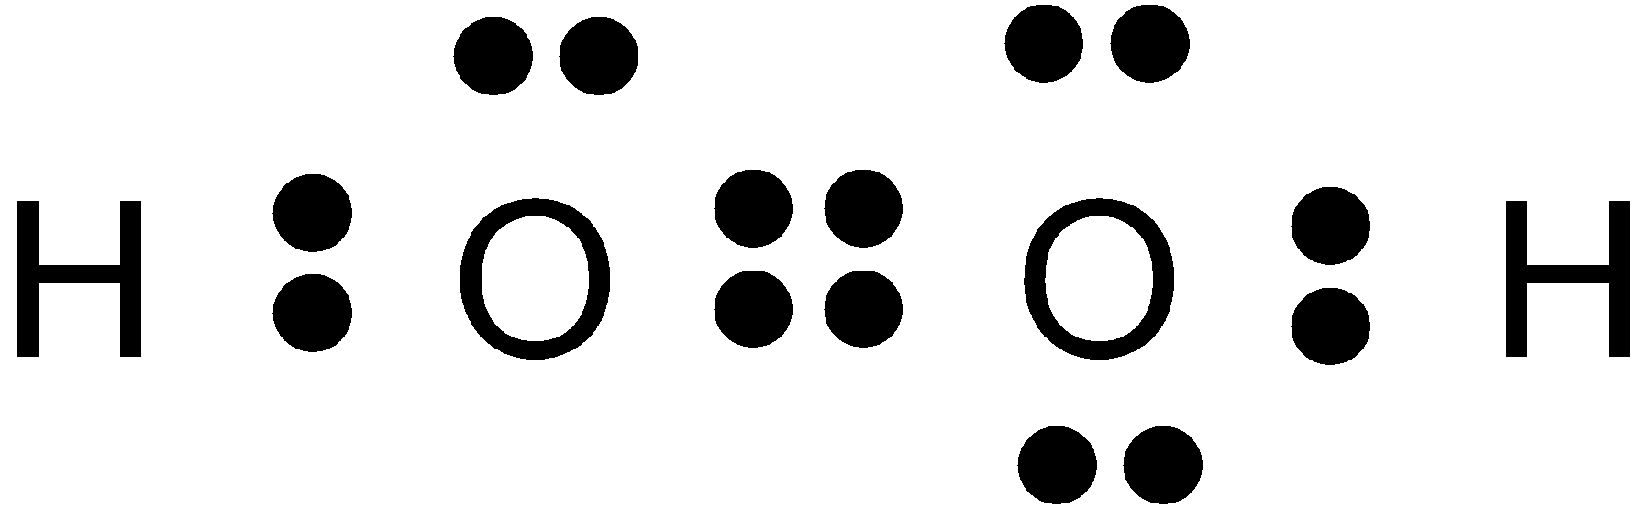

C) 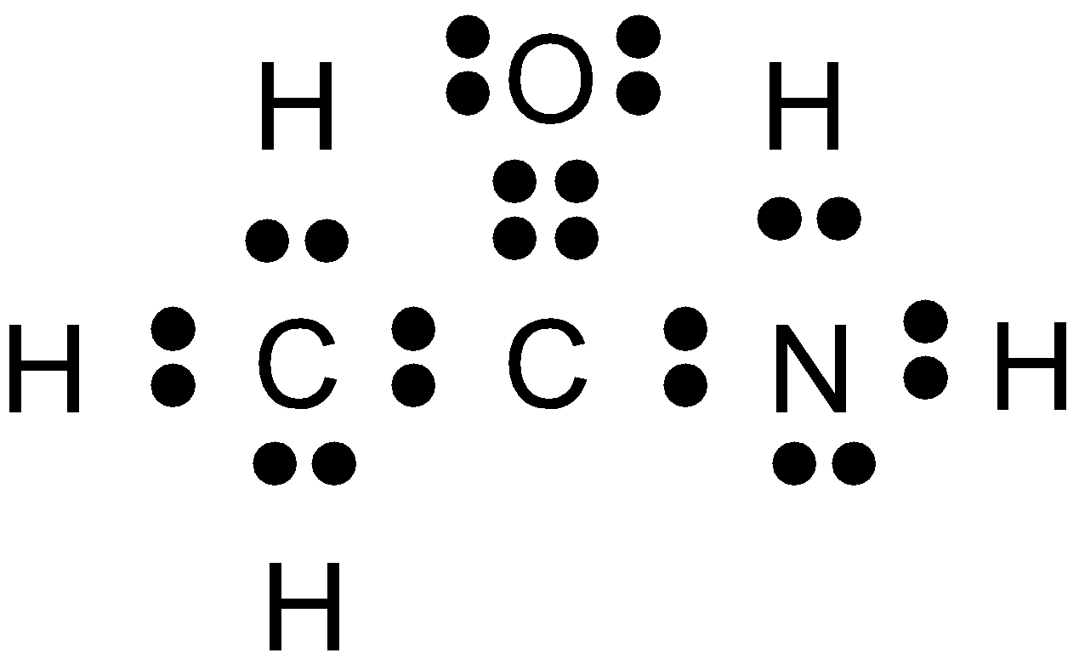 or 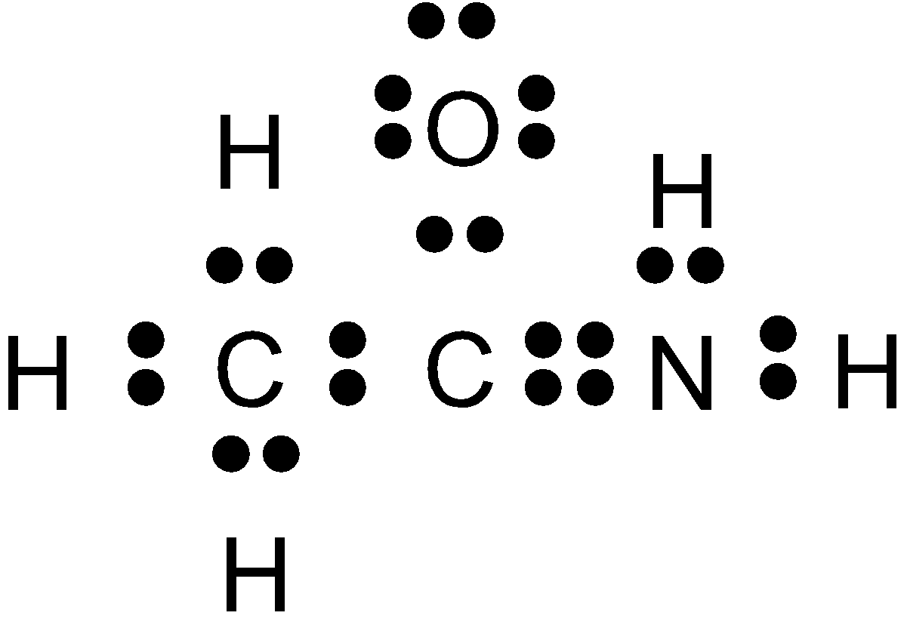
Resonance Structures

When more than one valid Lewis structure can be written for a molecule, the true structure is generally a mixture or hybrid of all of the possibilities. This most commonly occurs when a double bond could be written between a central atom and two or more identical attached atoms. Under these circumstances, all of the possible structures are shown with a double arrow between each as shown in the examples below. These are called resonance structures. This is not to imply that the molecule flips around between the possibilities, but instead that the real molecule is an average of them.

EXAMPLE

Write resonance structures for the following: NO₃⁻¹

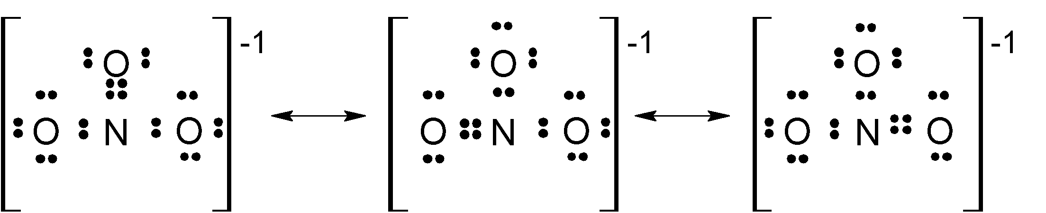

Note that because all three oxygen atoms are really equivalent, the double bond could be written between the nitrogen atom and any of the three oxygen atoms. The actual molecule is a hybrid of all three structures, meaning that all three bonds are equivalent with each N-O bond being about 1 and 1/3 (rather than two single bonds and 1 double bond.)

PROBLEMS

1)Write the required equivalent resonance structures for the following molecules and ions:

O₃

CO₃⁻²

2) For each, draw the possible resonance structures that the molecule can have. Assign formal charges in each and circle the most plausible structure for the molecule.

OCN⁻

N₂O

SO₄²⁻

XeO₃

POF₃

