Practicing Calculating pH Name ___________________________
For each scenario:
- Write the balanced chemical equation for the reaction.
- Determine whether the acid/base indicated is weak or strong
- Calculate the pH, pOH, [H⁺]/[OH⁻] concentrations for each acid/base mentioned.
Use the following equations to help you determine your answers:
pH = -log[H⁺] [H⁺] = 10^{-pH}
pOH = -log[OH⁻] [OH⁻] = 10^{-pOH}
pH + pOH = 14 [H⁺][OH⁻] = 1×10⁻¹⁴ mol dm⁻³
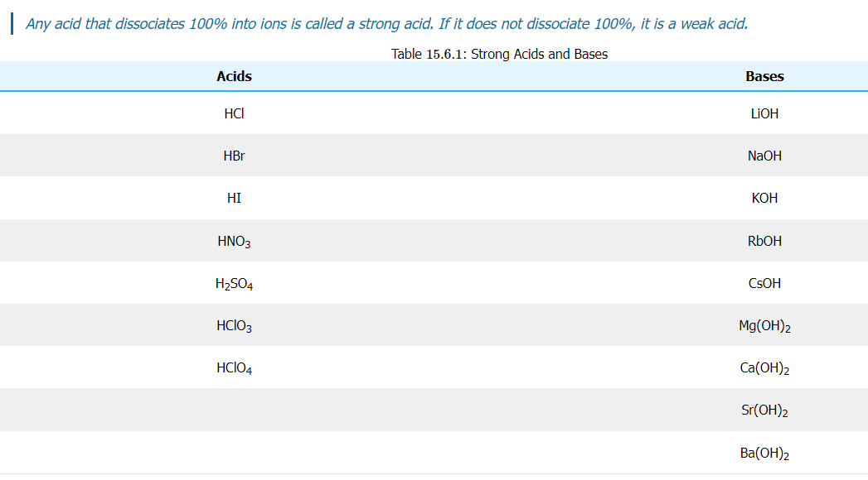
- When dissolved in water, ammonia reacts partially to yield hydroxide ions. Under typical conditions, only about 1% of the dissolved ammonia is present as ammonium ions. The pH of a particular solution of ammonia is determined to be 11.2.
- Antacids such as magnesium hydroxide combine with hydrochloric acid in the stomach in a neutralization reaction. Prior to being neutralized, the pOH of a solution of magnesium hydroxide is 4, while the [H⁺] concentration of hydrochloric acid is 0.040 mol dm⁻³.
- Hypochlorous acid is used as an effective disinfectant on surfaces and wounds. When it reacts with water, the equilibrium concentration of [H⁺] is measured to be 3.98 × 10⁻⁴ mol dm⁻³.
- A solution of barium hydroxide is neutralized with a solution of nitric acid. Prior to neutralization, the solution of barium hydroxide had a measured [OH⁻] concentration of 0.070 mol dm⁻³. Nitric acid has a pH of 3.01.
- Water itself ionizes slightly. The [H⁺] concentration of water at 298 K is 1.00 × 10⁻⁷ mol dm⁻³.

