
- Explain the difference between strong and weak acids.
Name ____________________

Understanding buffers
............................................................................................................................................................................
............................................................................................................................................................................ ............................................................................................................................................................................
- Using Le Chatelier’s principle, predict what will happen if:
  - solution containing hydrogen ions is added to a solution of hydrochloric acid
............................................................................................................................................................................
............................................................................................................................................................................
............................................................................................................................................................................
a solution containing hydrogen ions is added to a solution of hydrofluoric acid?
............................................................................................................................................................................
............................................................................................................................................................................
............................................................................................................................................................................
- Explain how it is possible for a weak acid system to be in equilibrium while reactions still occur.
............................................................................................................................................................................
............................................................................................................................................................................
............................................................................................................................................................................

- Write an equation showing the addition of acetic acid to water. Include water in the equation, and identify any conjugate acid/base pairs.

- Which has a better buffering capacity: hydrochloric acid or hydrofluoric acid? Explain your answer. (Remember, a buffer is a substance that stabilises pH)
............................................................................................................................................................................
............................................................................................................................................................................
............................................................................................................................................................................
- Explain how HF could act as a buffer if a small amount of NaOH was added. Include chemical equations to aid your explanation.
- The following graph shows what happens to pH when a strong base is added to a weak acid. Explain the shape of this curve using your knowledge of buffering.
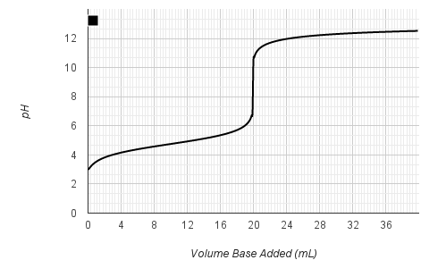
............................................................................................................................................................................
............................................................................................................................................................................
............................................................................................................................................................................
............................................................................................................................................................................
............................................................................................................................................................................
............................................................................................................................................................................
- Explain what the term ‘buffering capacity’ means at the molecular level.
............................................................................................................................................................................
............................................................................................................................................................................
............................................................................................................................................................................
............................................................................................................................................................................
............................................................................................................................................................................

Part 2: Applying buffering principles to buffering in the human body
Our bodies require energy to carry out their daily functions. This energy is created in cells by the reaction of glucose and oxygen. Carbon dioxide and water are also produced, and they react further to produce hydrogen ions.
When we exercise, breathing rate increases to supply more oxygen to our cells. However, after a certain point it becomes difficult to provide enough oxygen in this way, and other chemical reactions that produce excess lactic acid occur. This increases the concentration of hydrogen ions in the blood, which causes pH to decrease. Normal blood pH is 7.4. Changes in this level can cause illness or death, so the body must have mechanisms in place to maintain constant pH. Blood plays a crucial role in this process.
Several buffering systems are present in the circulatory system. The most important of these is the carbonic acid/hydrogencarbonate buffer system:
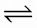
H⁺(aq) +HCO3⁻(aq) H₂CO3 H₂O(l) + CO2 (g)

- This is a two-part equilibrium reaction. Which reaction is an acid/base reaction? Explain your answer.
............................................................................................................................................................................
............................................................................................................................................................................
............................................................................................................................................................................

- Use Le Chatelier’s principle and the buffering equation above to explain why:
  - A person breathes harder and exhales more carbon dioxide when they exercise vigorously.
............................................................................................................................................................................
............................................................................................................................................................................
............................................................................................................................................................................

  - The kidneys remove hydrogencarbonate ions when blood pH is too high for buffering alone to stabilise (this condition is called alkalosis).
............................................................................................................................................................................
............................................................................................................................................................................
............................................................................................................................................................................
  - When a person hyperventilates the concentration of carbon dioxide in their blood decreases. Would this result in increased or decreased blood pH?
............................................................................................................................................................................
............................................................................................................................................................................
............................................................................................................................................................................
- It is important that the concentration of buffer in blood is high. Explain why.
............................................................................................................................................................................
............................................................................................................................................................................ ............................................................................................................................................................................

• The following diagram shows the buffer curve for the carbonic acid/hydrogencarbonate equilibrium reaction stated previously.
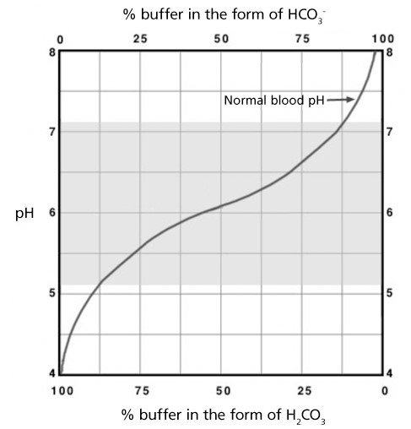
- Over what pH range is hydrogencarbonate a good buffer?
............................................................................................................................................................................

- The pH of blood is normally 7.4, which is outside the buffering region of HCO₃⁻ shown in the diagram above. Explain why it is still able to work as a buffer in the human body. (Think about differences between applying Le Chatelier’s principle to a laboratory experiment and the human body.)
............................................................................................................................................................................
............................................................................................................................................................................
............................................................................................................................................................................
............................................................................................................................................................................
............................................................................................................................................................................

